**Python FSD**

Python React Runing Capstone Phase 2 Project Solution



**Home Furnishing Application**

**Steps to be followed:**

1. Pull Phase 1 and Phase 2 projects github account
2. Create Docker image for both project and Docker compose file
3. Login to AWS account and create EC2 instance
4. Then push the code to git hub account
5. Install all required software to deploy ie git, Java, Jenkin, docker and docker compose
6. Login to Jenkin dashboard and Create Jenkin job responsible to pull the project from git and run the docker compose file
7. Test the application

**Step 1: Pull phase 1 and phase 2 Project from github account.**

1. Pull the project from git hub account phase 1 (python with Django) and phase 2 (react js). Both project available in below github account.
2. git pull **https://github.com/Kaleakash/ReactPythonCapstoneProjectDeploy.git**

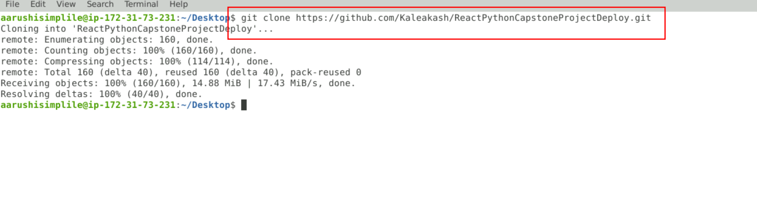

1. move inside a folder using cd command and remove .git folder. Which is responsible to remove remote repository details.

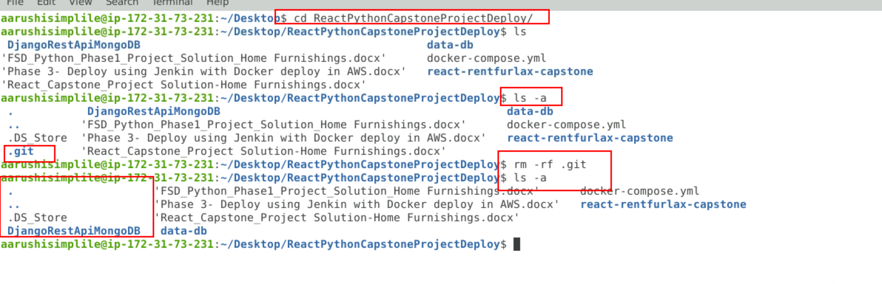

**Step 2: Now create the Dockerfile in both the folder. Which is responsible to create the image.**

2.1 DjangoRestApiMongoDB in folder

**requirements.txt** file which contains all dependencies which help to run the python with Django framework.

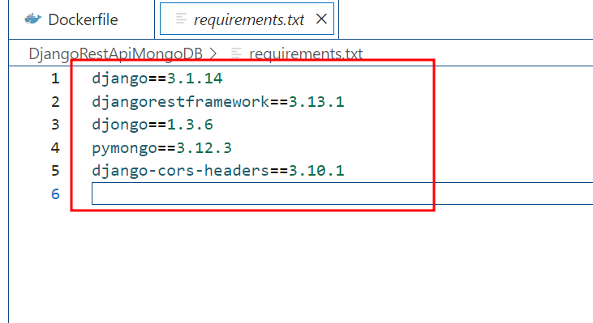

**Dockerfile**

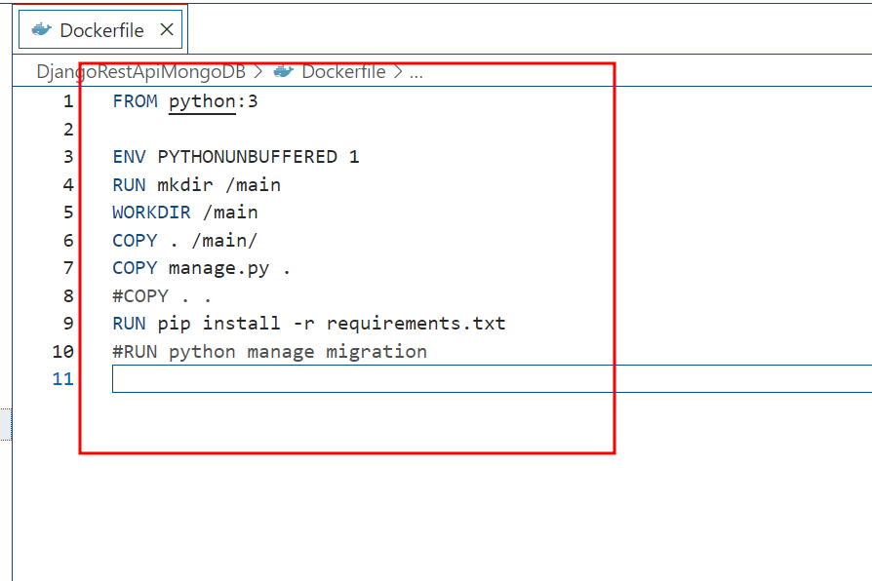

2.2 **react-rentfurlax-capstone** in folder

**Dockerfile**

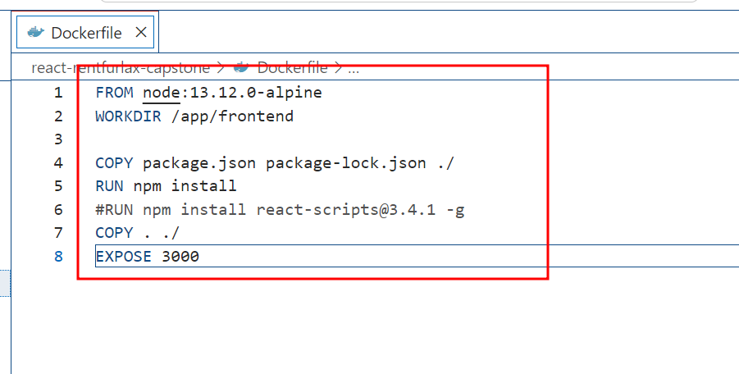

2.3 Now create docker-compose file

This file is responsible to create three service ie backend, frontend and database ie mongodb

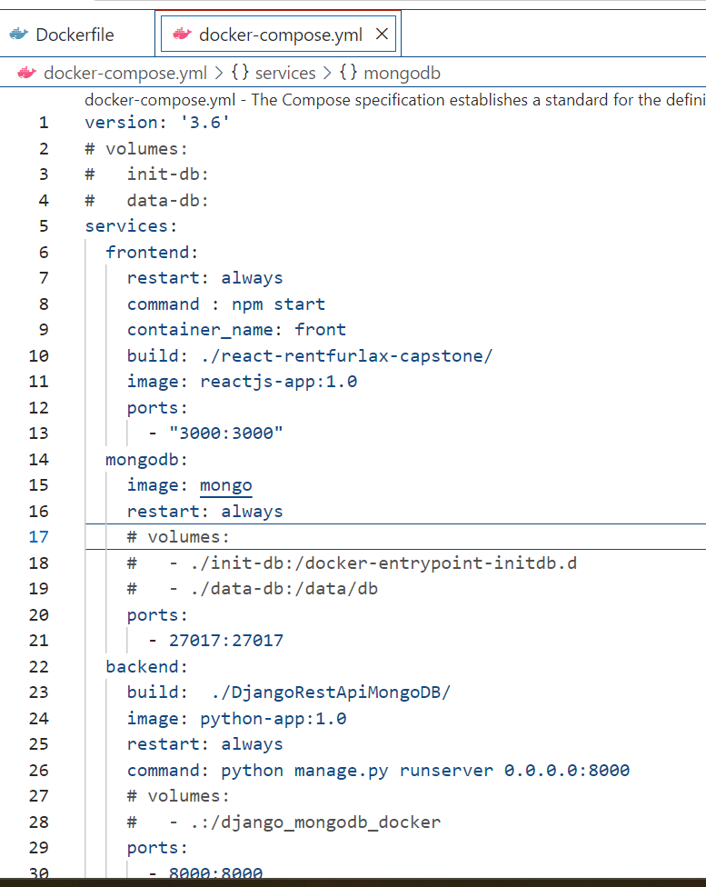

**docker-compose.yml file**

version: '3.6'

# volumes:

#   init-db:

#   data-db:

services:

  frontend:

    restart: always

    command : npm start

    container_name: front

    build: ./react-rentfurlax-capstone/

    image: reactjs-app:1.0

    ports:

      - "3000:3000"

  mongodb:

    image: mongo

    restart: always

    # volumes:

    #   - ./init-db:/docker-entrypoint-initdb.d

    #   - ./data-db:/data/db

    ports:

      - 27017:27017

  backend:

    build:  ./DjangoRestApiMongoDB/

    image: python-app:1.0

    restart: always

    command: python manage.py runserver 0.0.0.0:8000

    # volumes:

    #   - .:/django_mongodb_docker

    ports:

      - 8000:8000

    links:

      - mongodb

    depends_on:

      - migration

  migration:

    build: ./DjangoRestApiMongoDB/

    image: app

    command: python manage.py migrate

    volumes:

      - .:/django_mongodb_docker

    links:

      - mongodb

    depends_on:

      - make_migrations

  make_migrations:

    build: ./DjangoRestApiMongoDB/

    image: app

    command: python manage.py makemigrations

    volumes:

      - .:/django_mongodb_docker

    links:

      - mongodb

    depends_on:

      - mongodb

**Step 3: Login to AWS account :**

**3.1** Here using Python3 - Deploy the python application

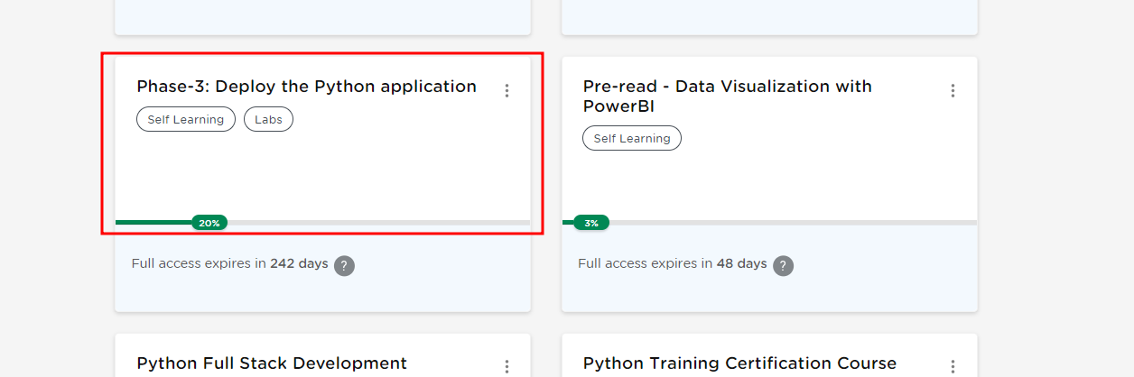

3.2 Then launch AWS lab

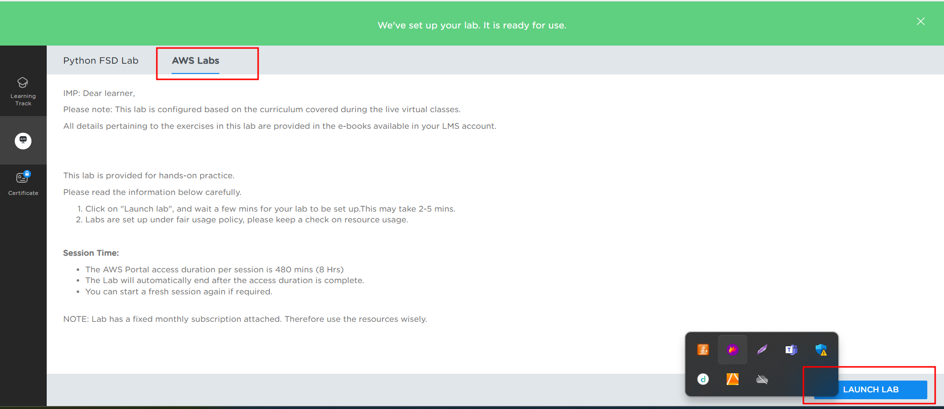

3.3 Login to AWS Account. Now click on EC2 instance which you can search in search box. If you are not able to view at the beginning.

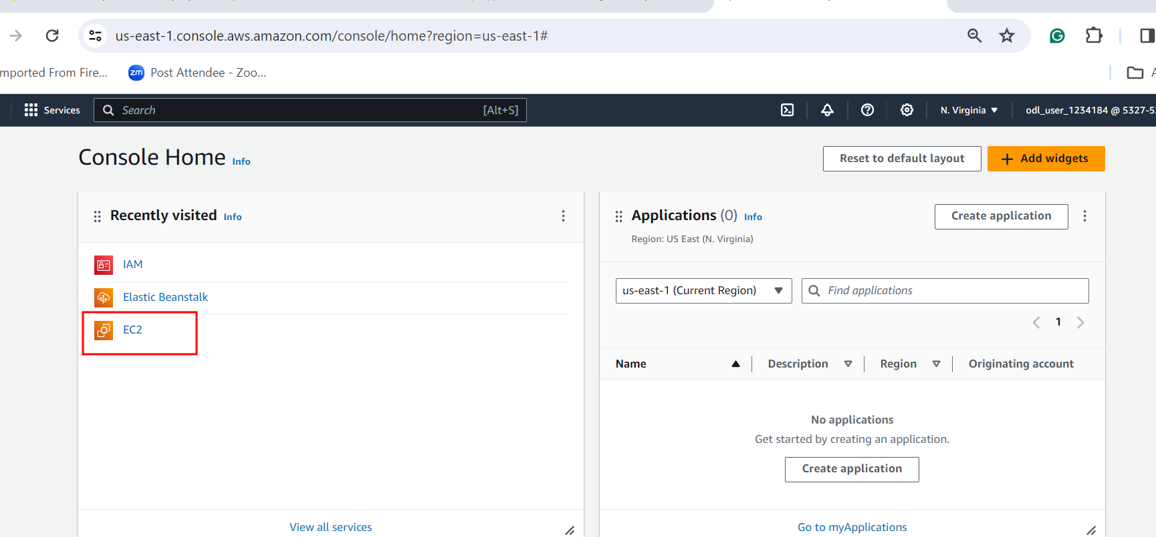

3.4 Now click on lunch instance button.

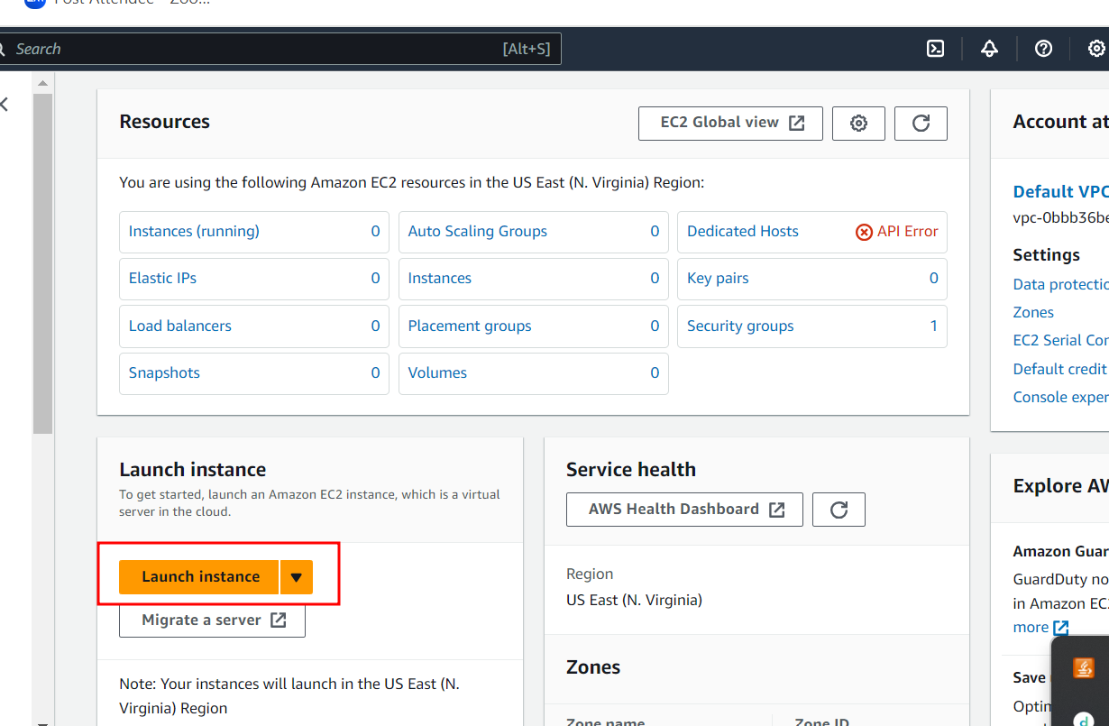

3.5 You can write any instance name and instance OS type is Amazon Linux.

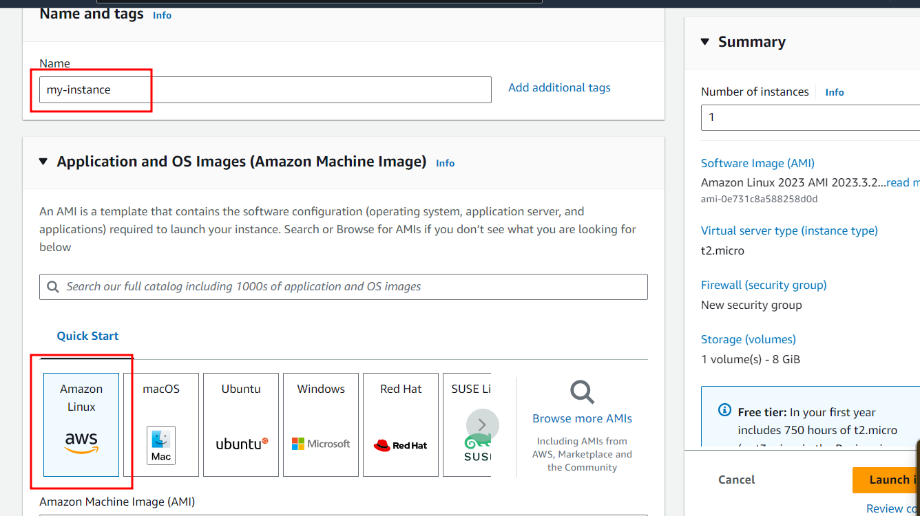

3.6 Amazon Machine Image (AMI) free tier and instance type t2.medium

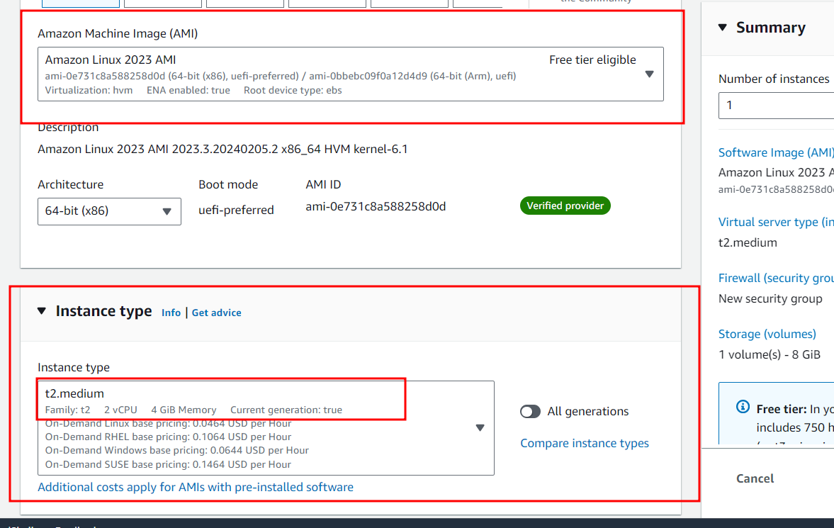

3.7 Now we need to create key-pairs which can help to connect EC2 instance using SSH client.

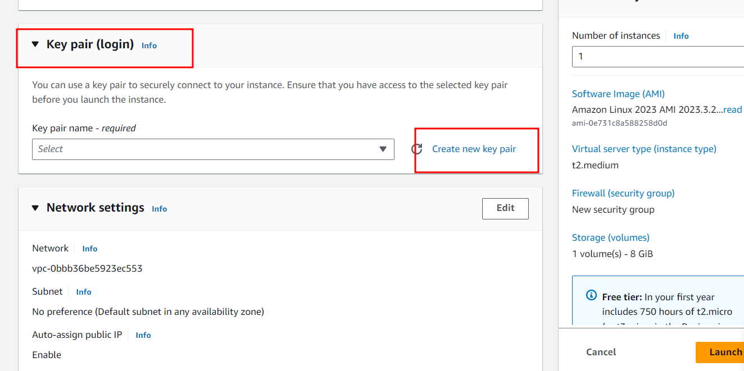

3.8 Write key name, key pair types and private key format and create the key pairs.

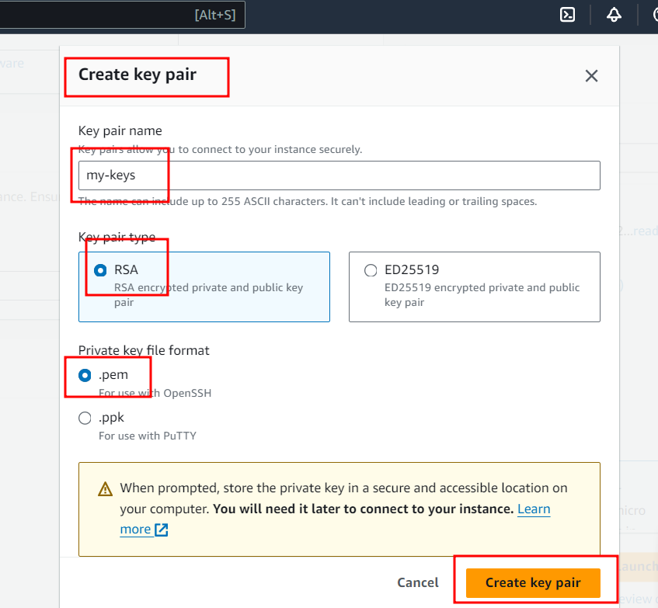

3.9. Network setting : create new security groups.

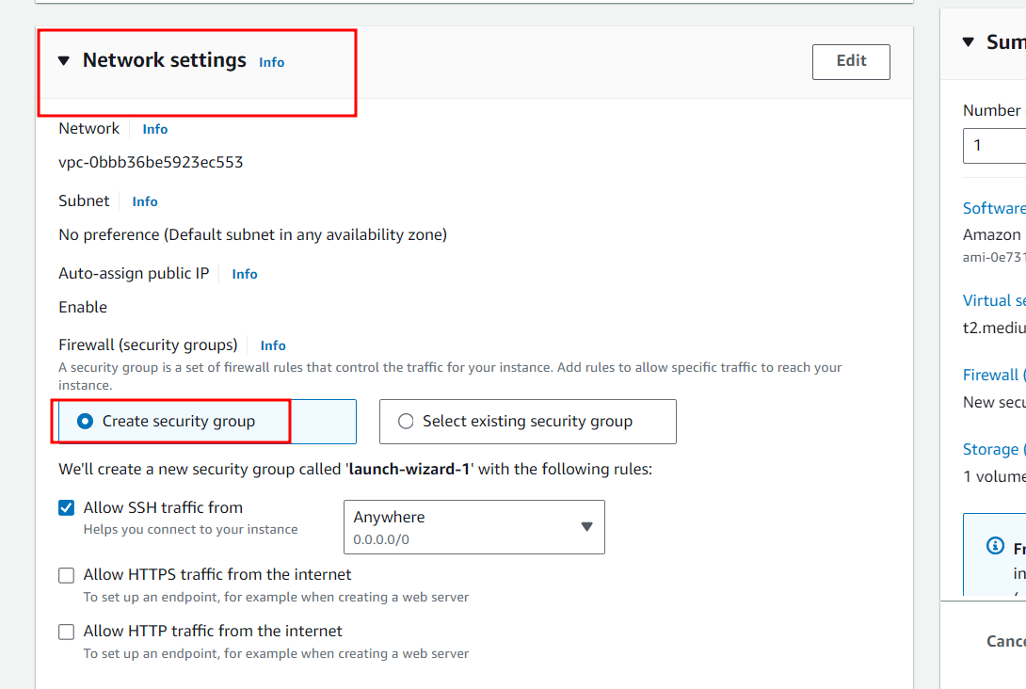

3.10 Configure storage: add new volume

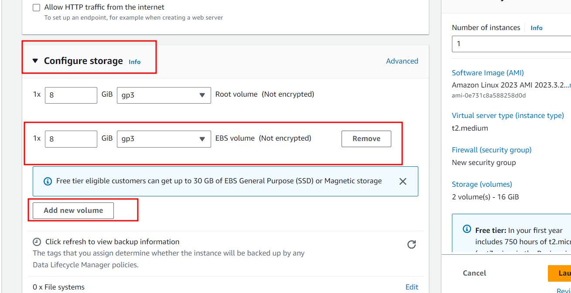

3.11 Launch instance type

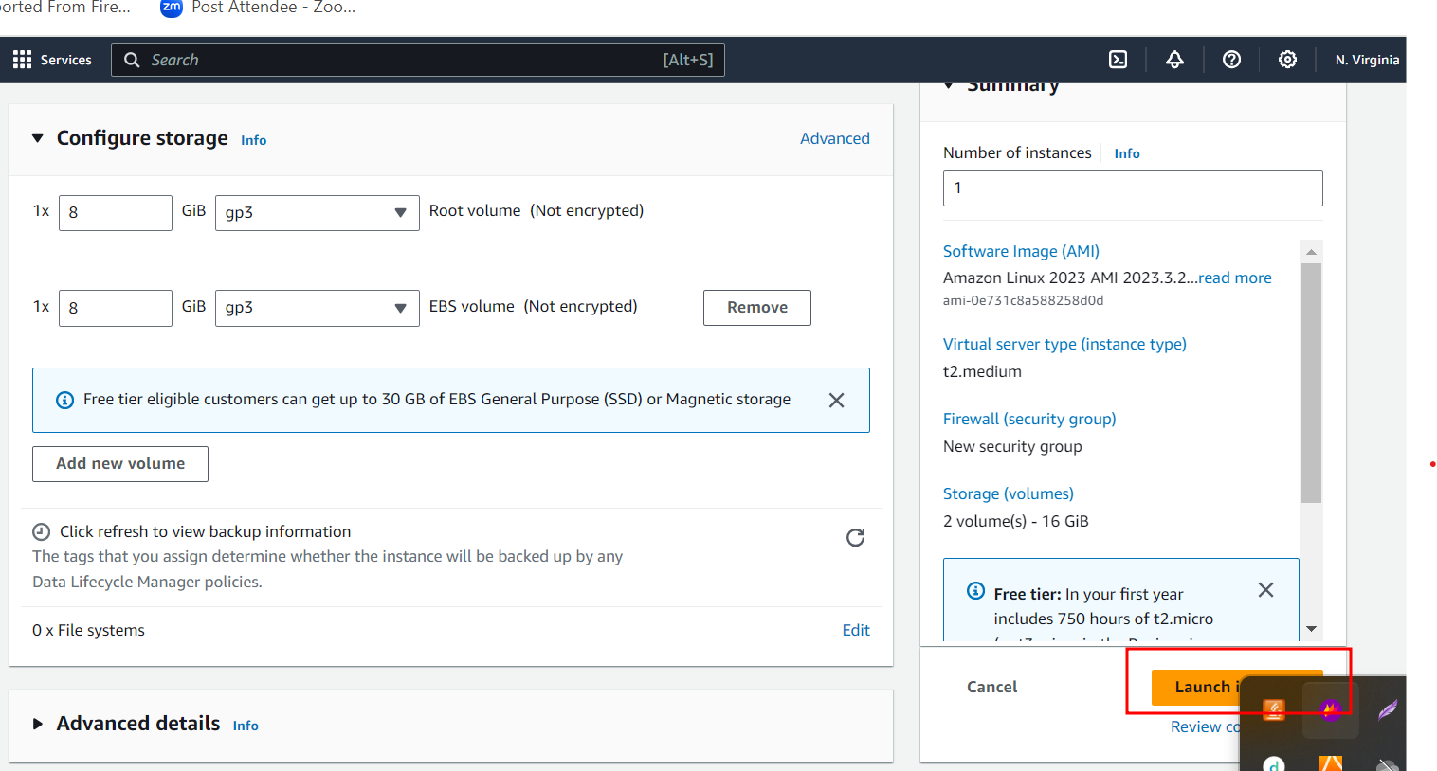

3.12 : if everything go file you can see below message.

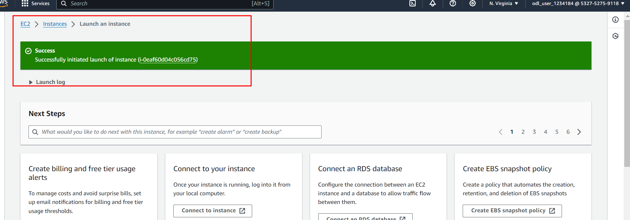

3.13 : Now you can check the status of EC2 instance. At the beginning instance is pending after few minutes it start running

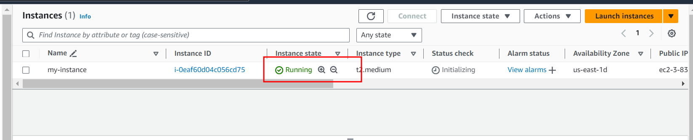

3.14. Now we need to open the port number to run the application. By default EC2 instance open 22 port number to connect EC2 instance using SSH client. So Jenkin use port number 8080, React JS use 3000 and Python with Django 8000.

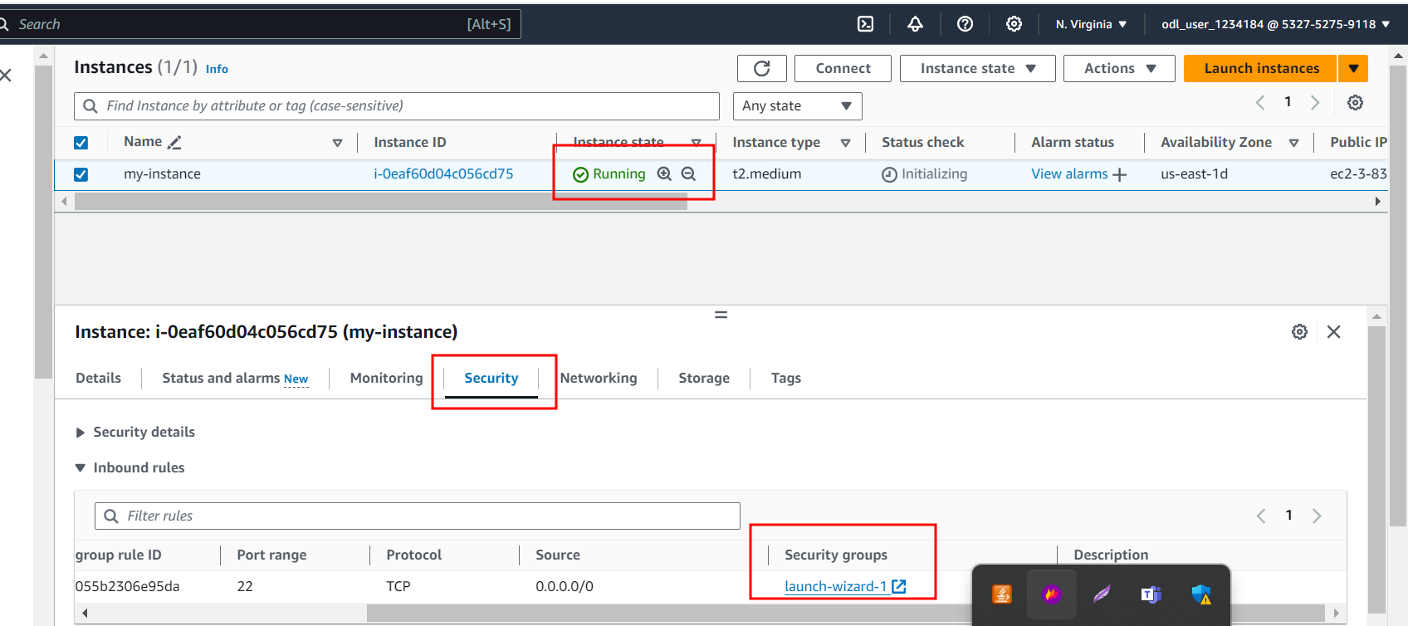

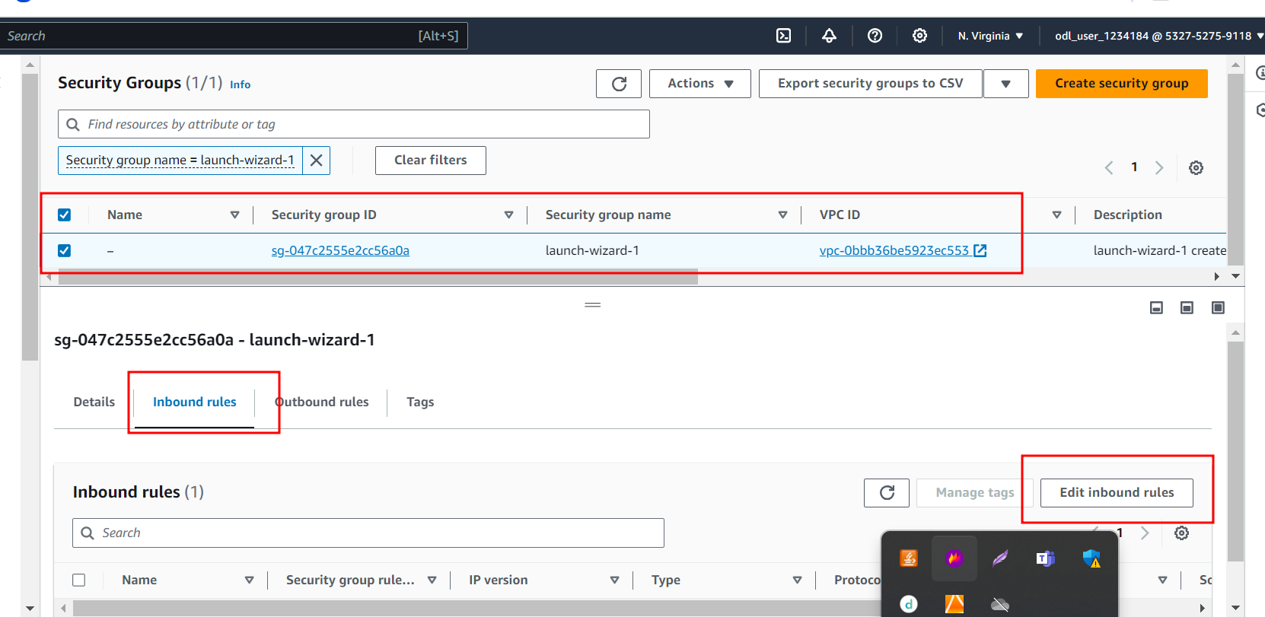

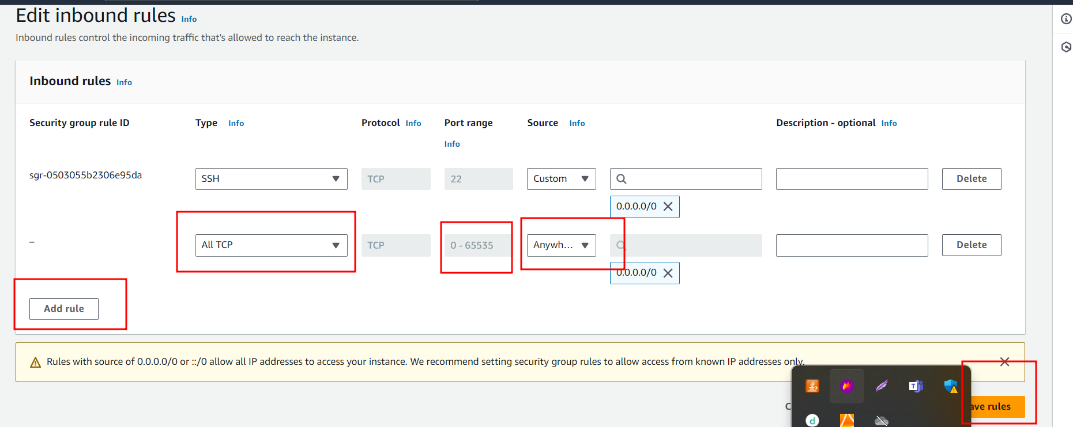

The above steps open All TCP port number from 0 to 65535.

3.15. Now you can connect the EC2 instance using browser or SSH client. Here I am using browser.

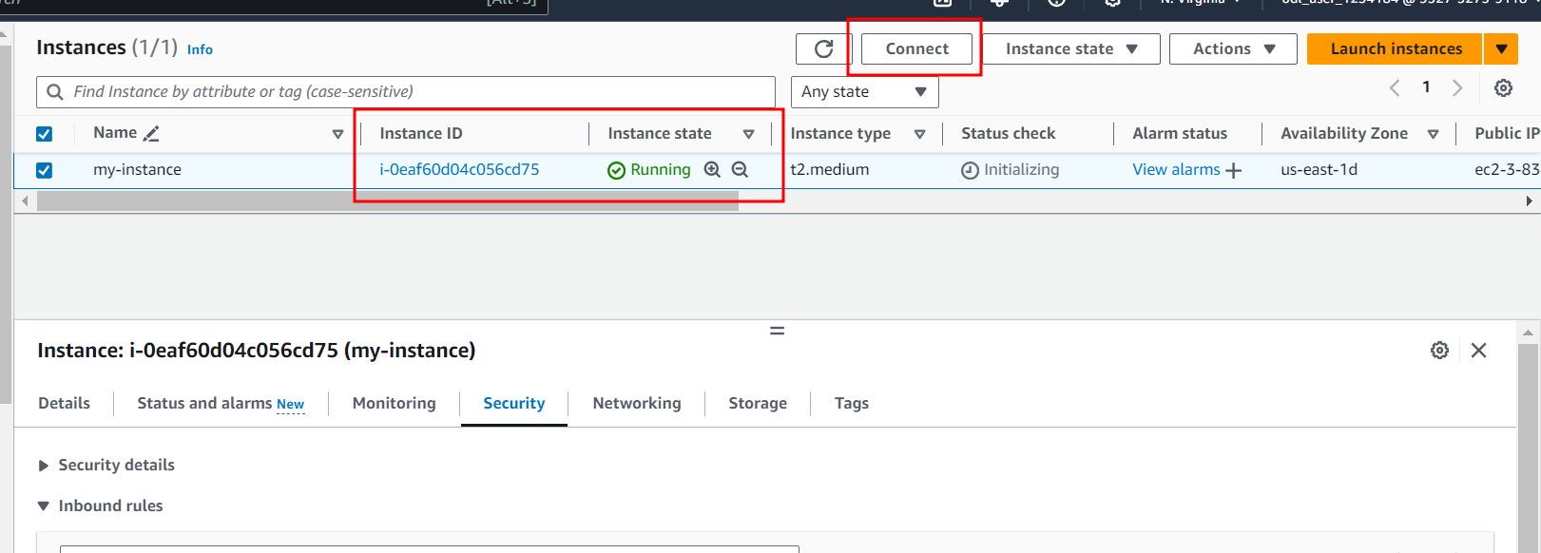

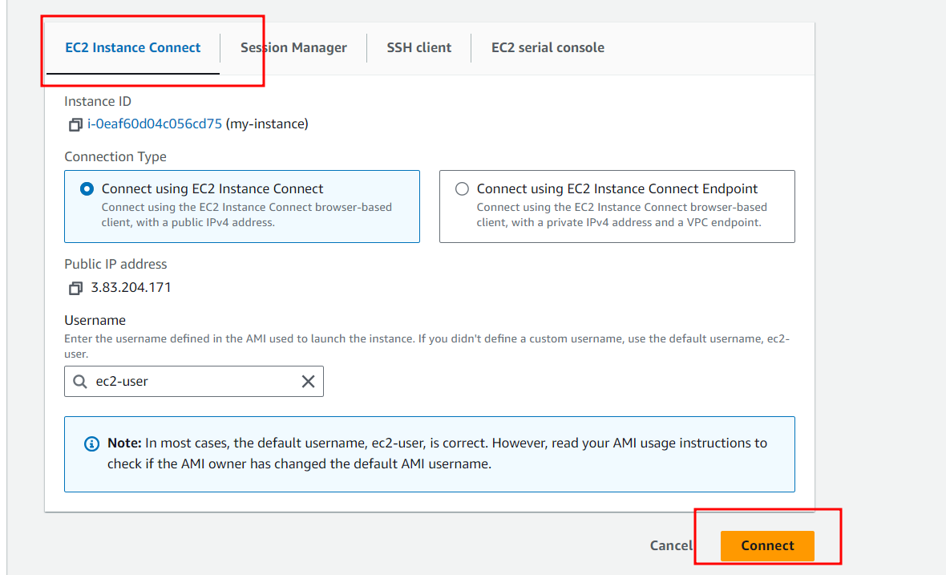

3.16 : You instance connected through browser. This instance provide public as well as private IP Address.

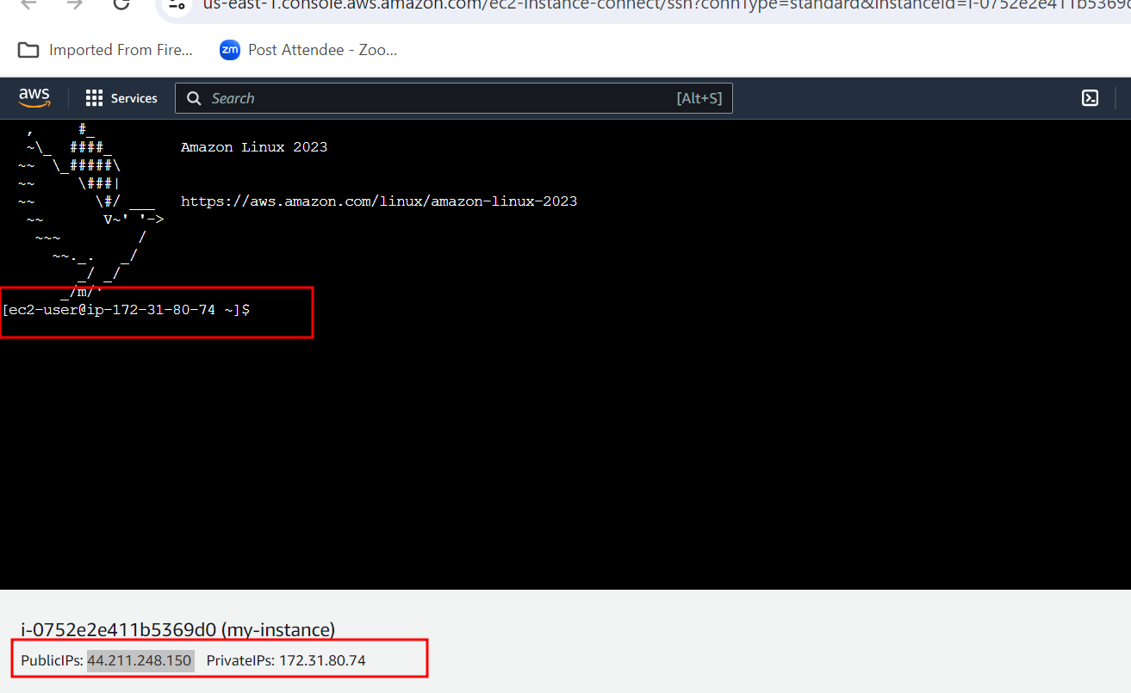

**Step 4: Then push the code to git hub account**

4.1 : In Virtual Lab Please do some changes in setting. Change the Public IP Address of your current instance.

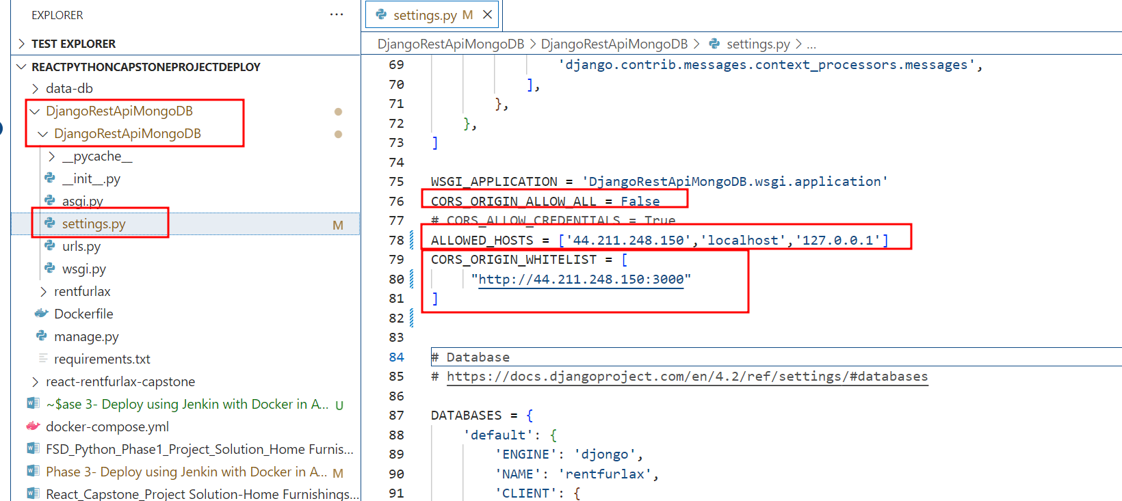

4.2 In React JS Project please change the public ip address in service folder both the file.

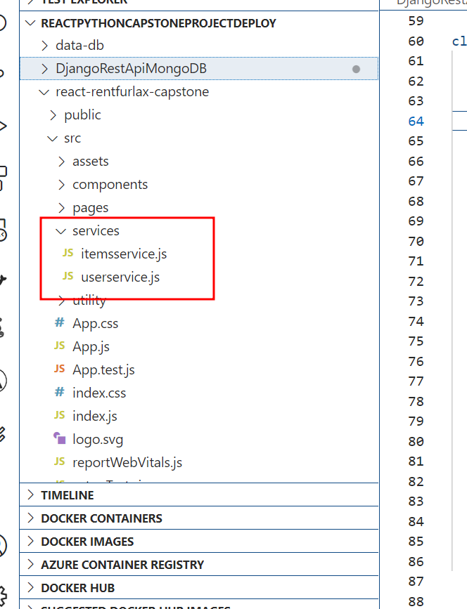

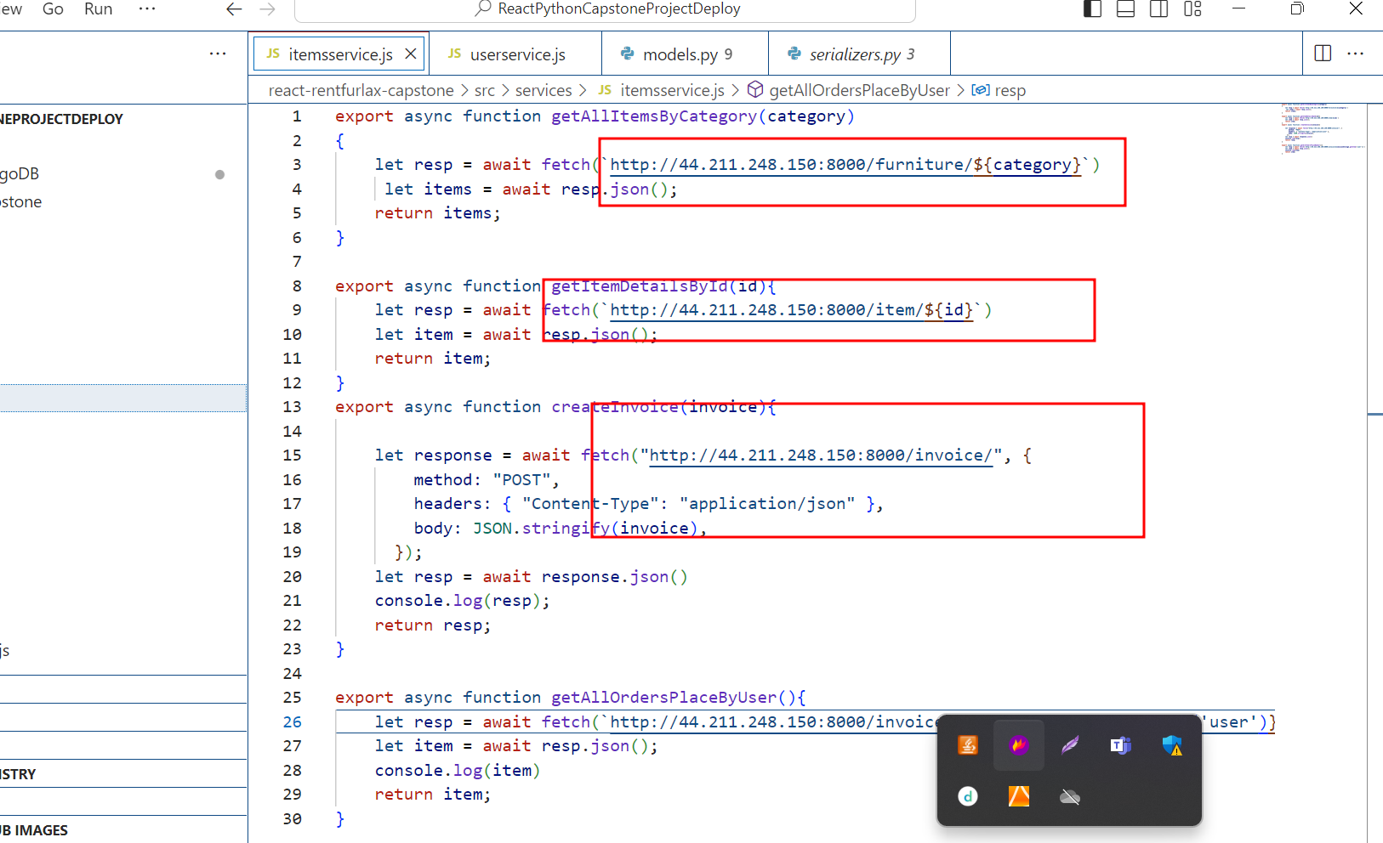

4.3 Follow below step to push your code to git hub account from Virtual Lab. Before push please create github account.

git init

git add .

git commit -m “initial commit”

git remote add origin URL

git push -u origin HEAD

**Step 5 : Install all required software to in EC2 instal to deploy ie git, Java, Jenkin, docker and docker compose**

5.1 : install git software which help to pull the project from git hub repository.

**sudo yum install git -y**

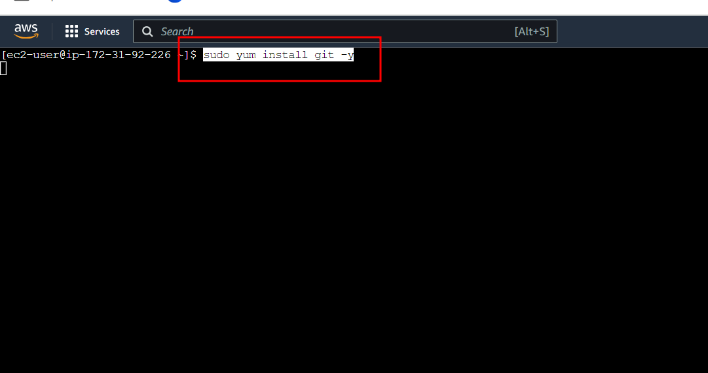

5.2 check the git version

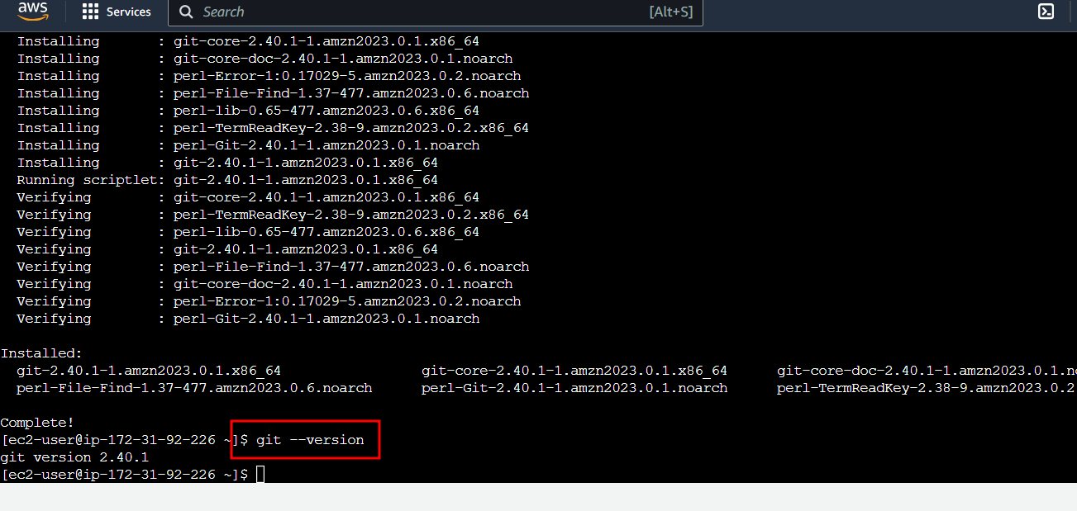

5.3 Now we need to install Java. Because Jenkin CI and CD tool is base upon java software.

**sudo yum install java**

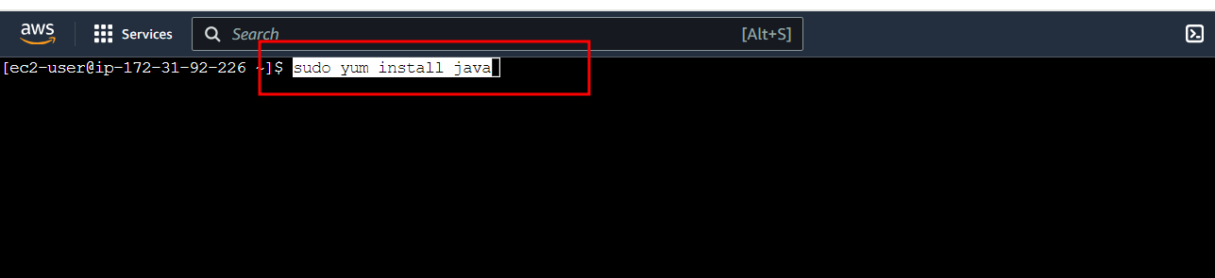

**5.4 Now check Java version**

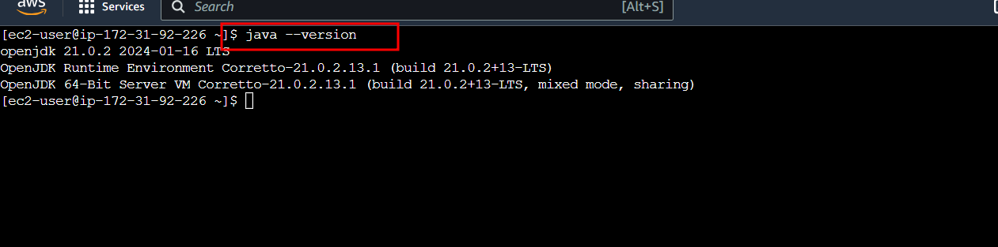

**5.5 Now we need to install the Jenkin software**

This below command to download the Jenkin software.

**sudo wget -O /etc/yum.repos.d/jenkins.repo** [**https://pkg.jenkins.io/redhat/jenkins.repo**](https://pkg.jenkins.io/redhat/jenkins.repo)

import the Jenkin keys.

**sudo rpm --import** [**https://pkg.jenkins.io/redhat-stable/jenkins.io-2023.key**](https://pkg.jenkins.io/redhat-stable/jenkins.io-2023.key)

Install the Jenkin software

**sudo yum install jenkins**

start the Jenkin service

**sudo service jenkins start**

To check the Jekin software status

**sudo systemctl status jenkins**

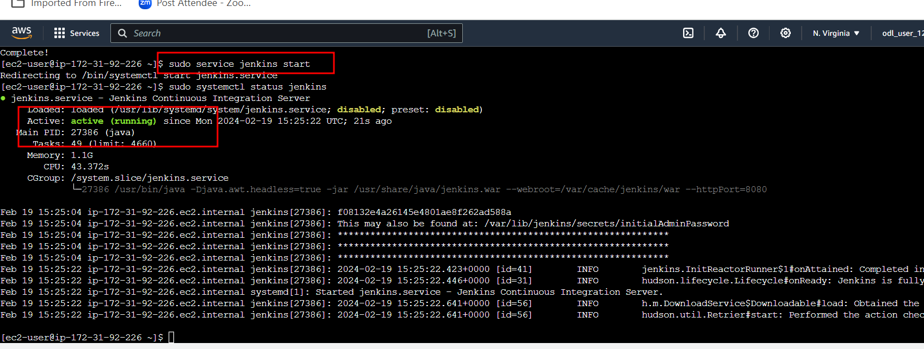

Note : use Cntr + C or Cntr + D to terminate that screen.

The initial admin password

**sudo cat /var/lib/jenkins/secrets/initialAdminPassword**

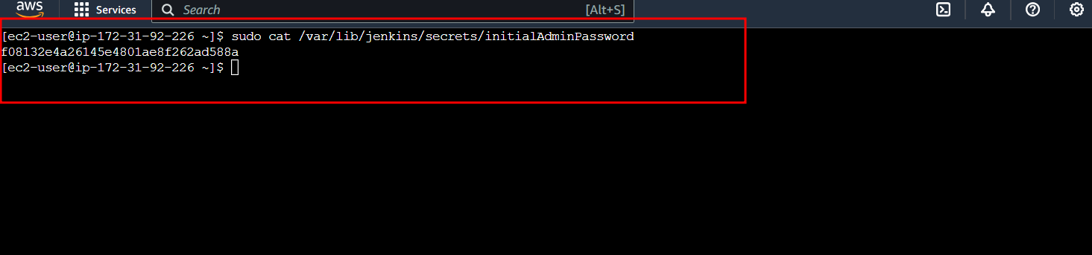

**5.6 Now open the Jenkin with your instance public IP Address with port number 8080**

[**http://publicIdAddress:8080**](http://publicIdAddress:8080)

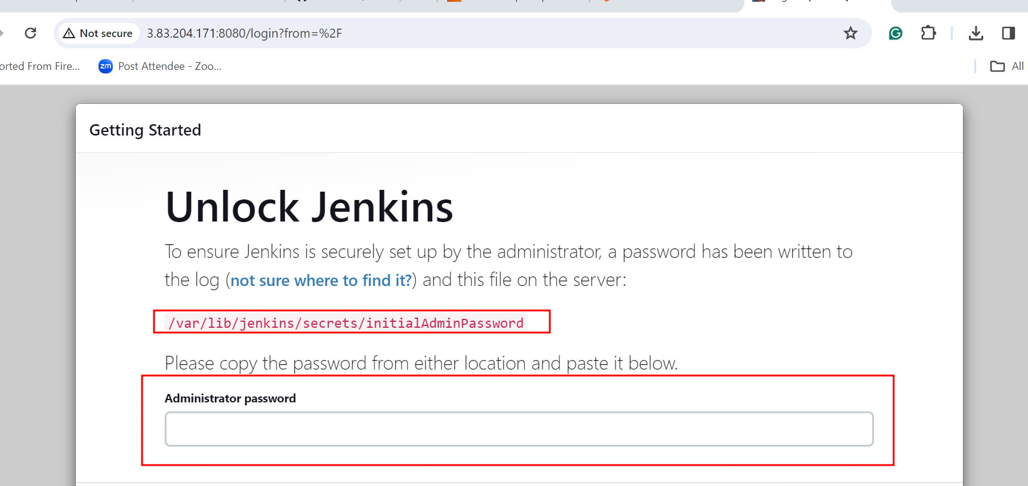

**5.7 Please copy and paste password from EC2 instance terminal. It initial instal the suggested plugin**

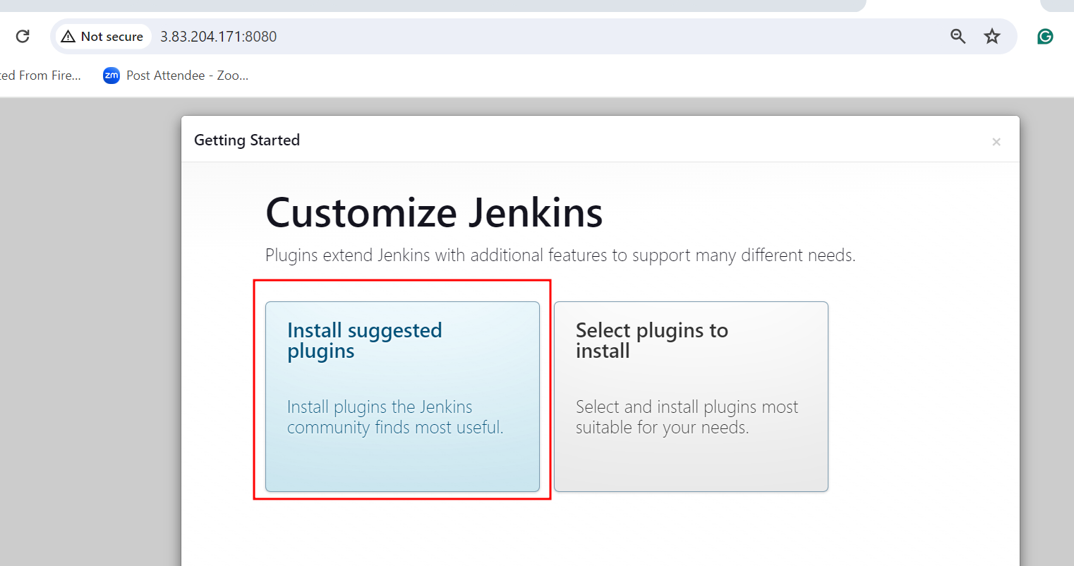

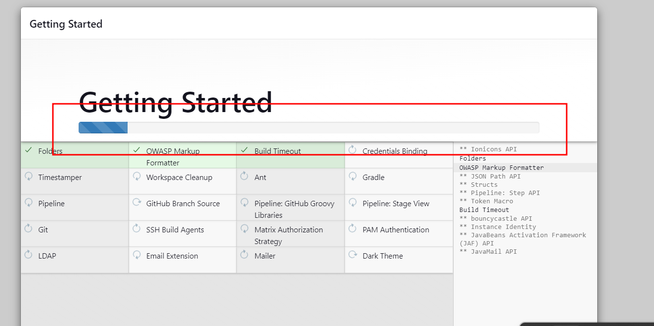

**5.8 : create the account with your personal details.**

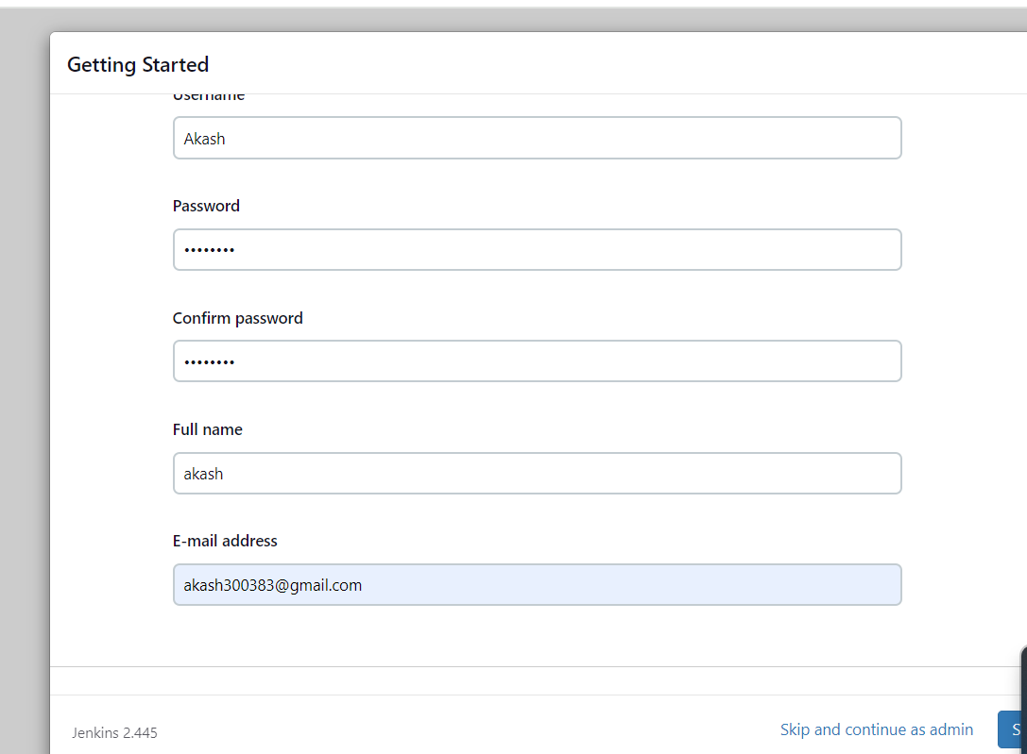

**5.9 here you can click save and finish.**

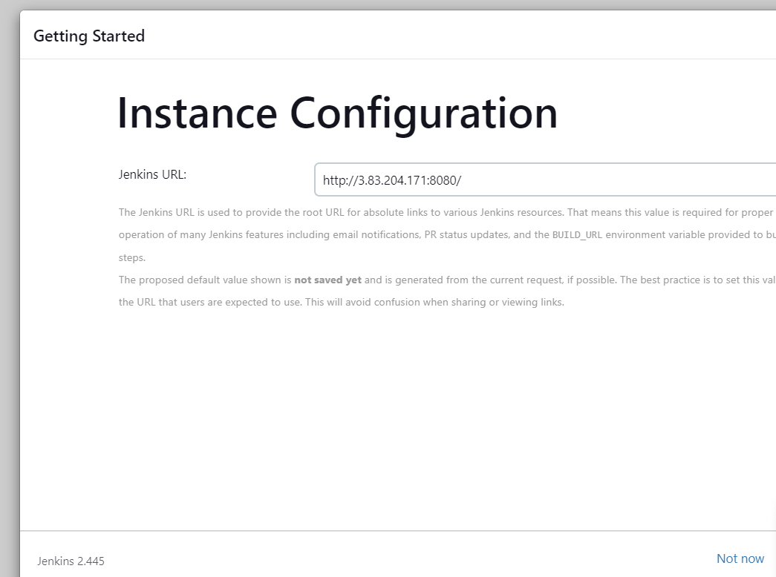

**5.10 : Now you need to install the Docker and Docker compose**

Below command install the docker

**sudo yum install docker**

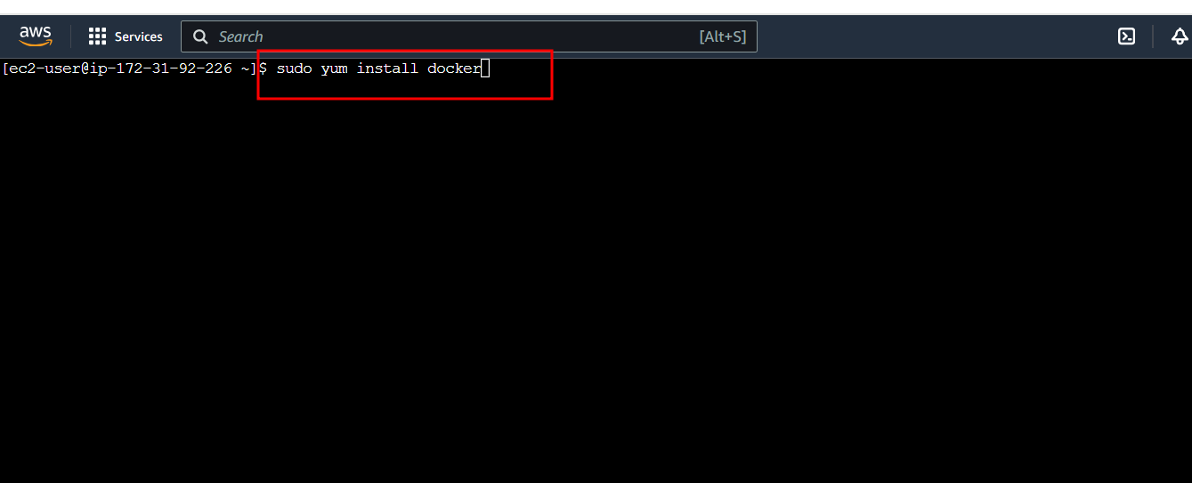

Below command start the docker service

**sudo service docker start**

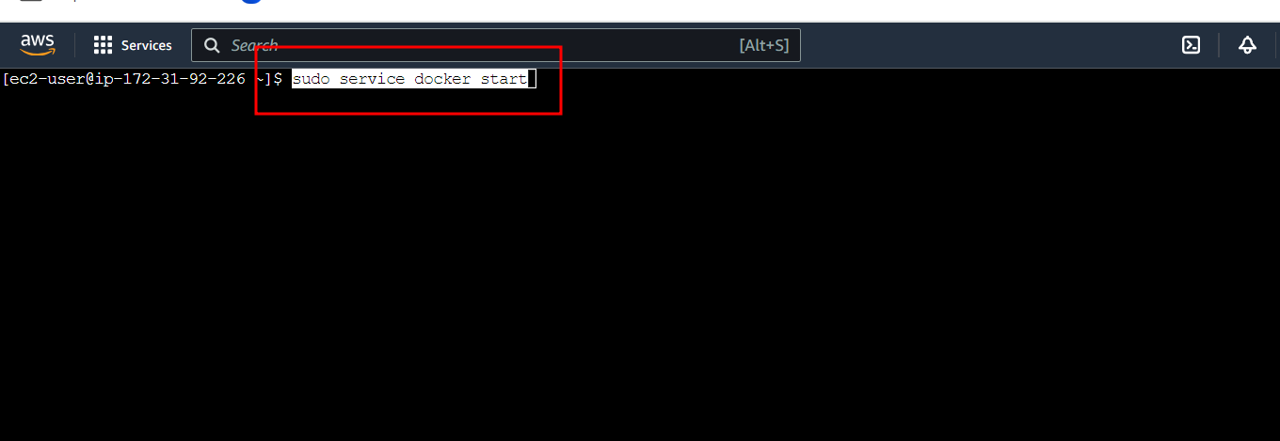

Below command check the status of the docker

**sudo docker info**

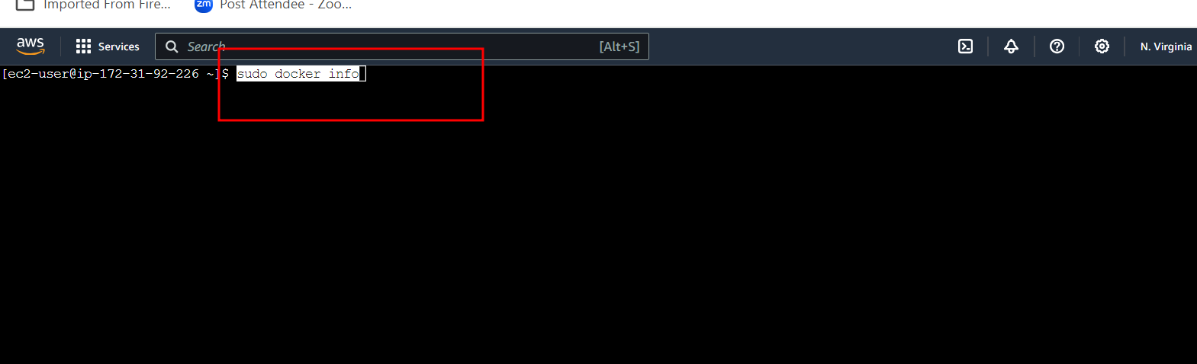

Download the current stable release of Docker Compose

**sudo curl -L https://github.com/docker/compose/releases/latest/download/docker-compose-$(uname -s)-$(uname -m) -o /usr/local/bin/docker-compose**

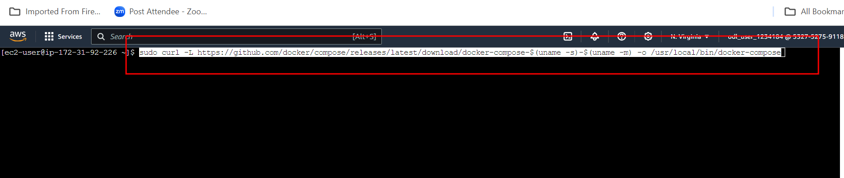

Give the permission

**sudo chmod +x /usr/local/bin/docker-compose**

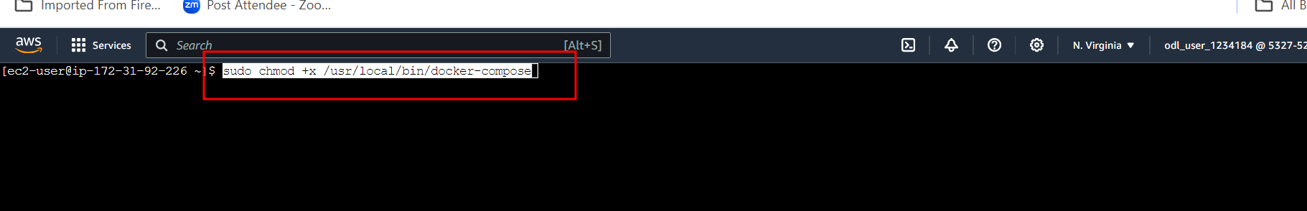

check the Docker version

**docker-compose version**

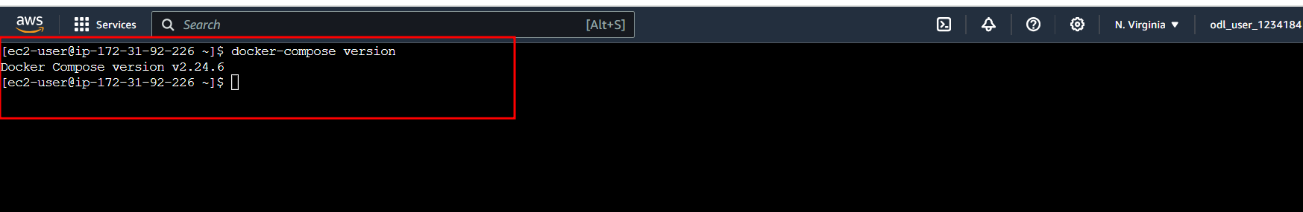

**5.11 :** Now we need create the group and add user, Jenkin and Docker to use the resource.

Create the docker group

**sudo groupadd docker**

Add docker and Jenkin in user mode

**sudo usermod -a -G docker jenkins**

Add docker and ec2 instance user

**sudo usermod -a -G docker ec2-user**

give the permission to run the docker in Jenkin environment.

**sudo chmod 777 /var/run/docker.sock**

restart the Jenkin

**sudo service jenkins restart**

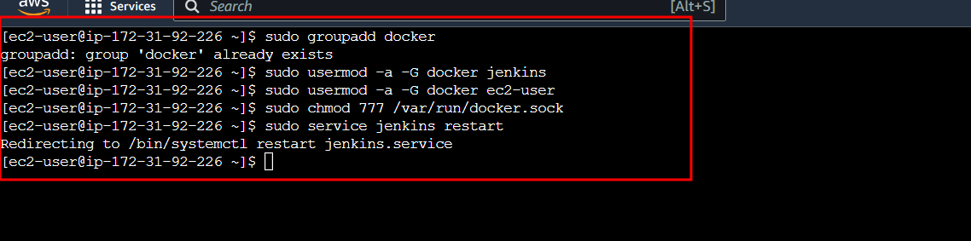

**Step 6 : Now login the Jekin dashboard**

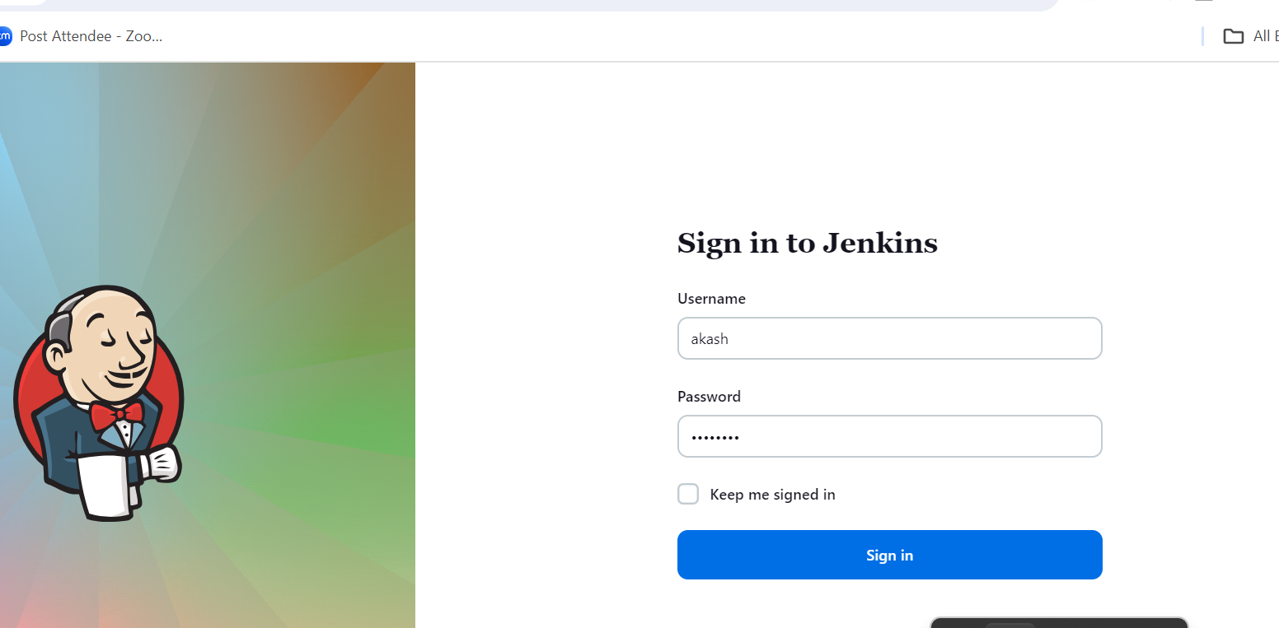

**6.1 Now you need to create the Jenkin job.**

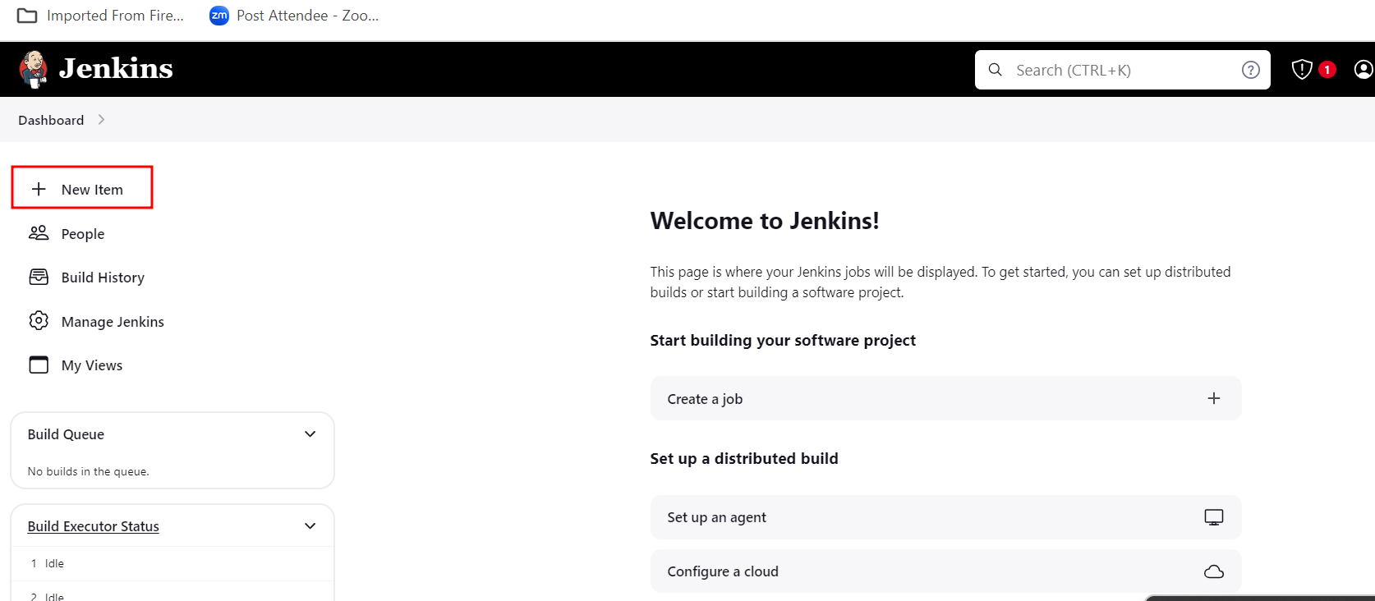

**6.2 Now you need to create the Jenkin job**

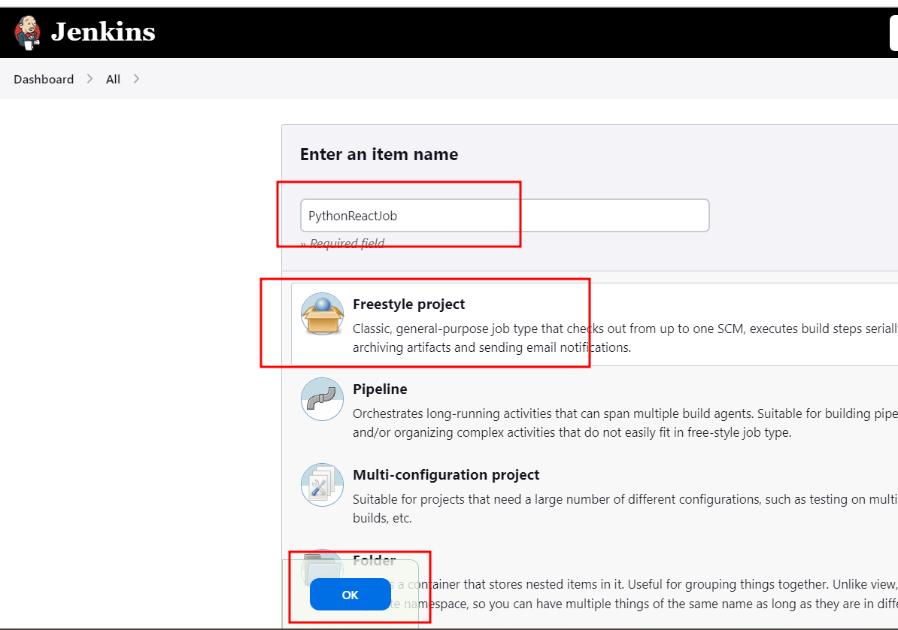

**6.3 General option in job**

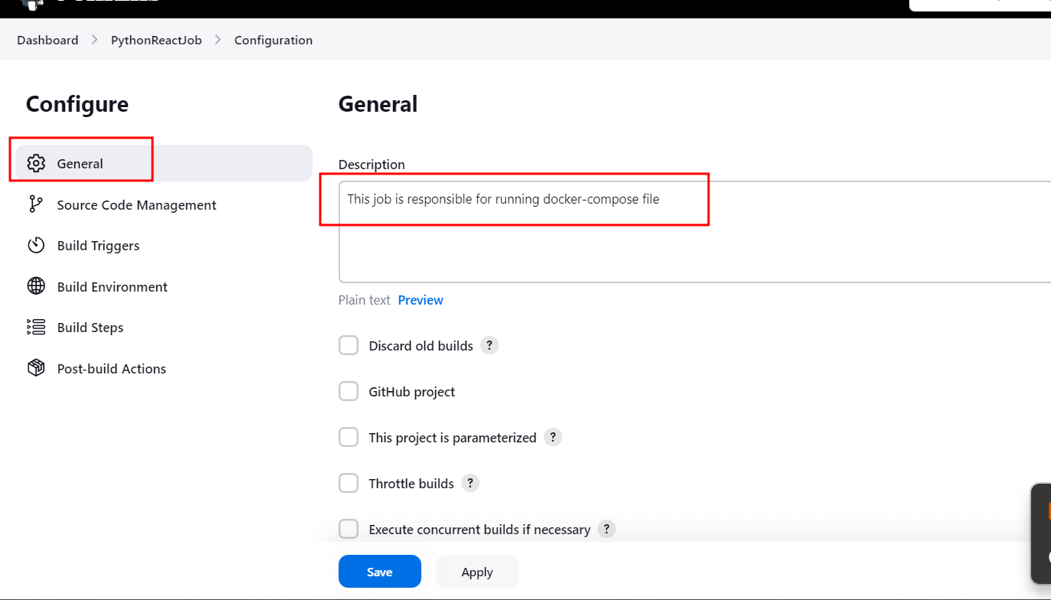

**6.4 In Source code management, please select the git option. Provide the Git reposit URL and provide the branch name ie may be master or main.**

[**https://github.com/Kaleakash/ReactPythonCapstoneProjectDeploy.git**](https://github.com/Kaleakash/ReactPythonCapstoneProjectDeploy.git)

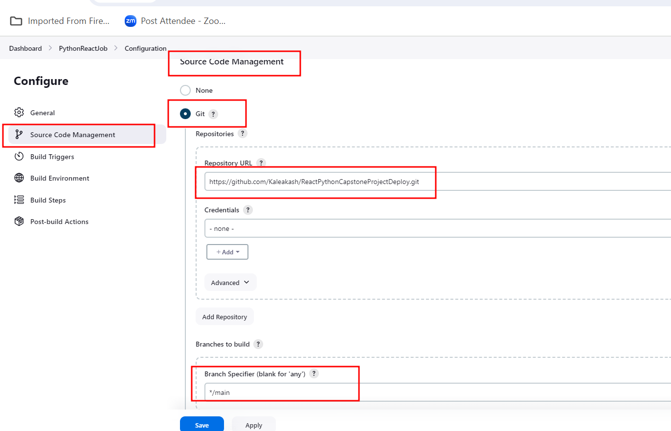

**6.5 Build trigger option. Poll SCM with * * * * *. So Jenkin check with every minute any changes happen in git hub account if any changes it will build the job.**

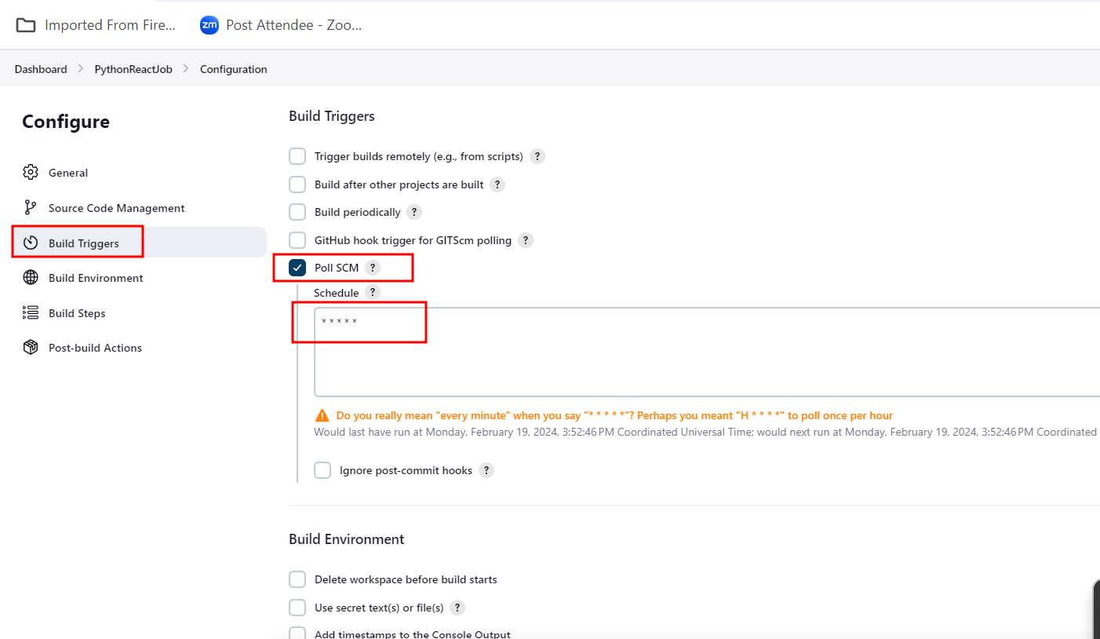

**6.6 In Build option we can write the command to run the docker compose file which is responsible to run three container as well as we can verify image and container details.**

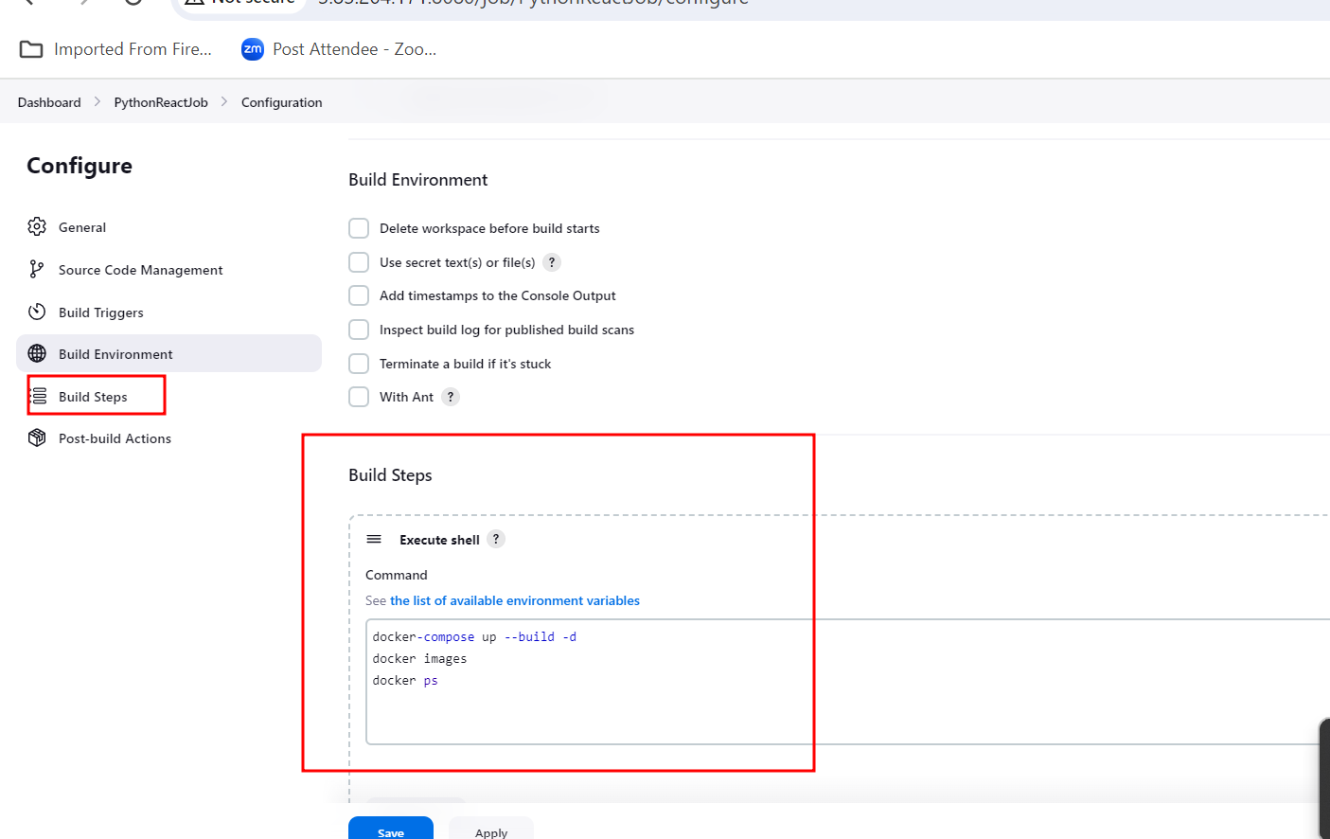

**6.7 : Now you can save and build the projects.**

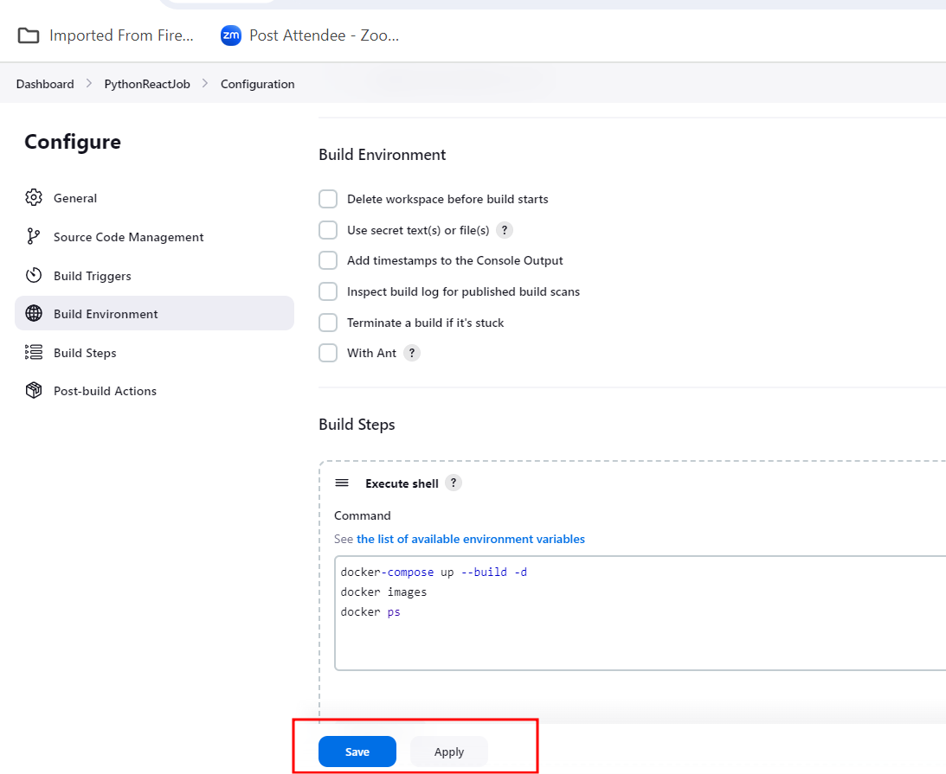

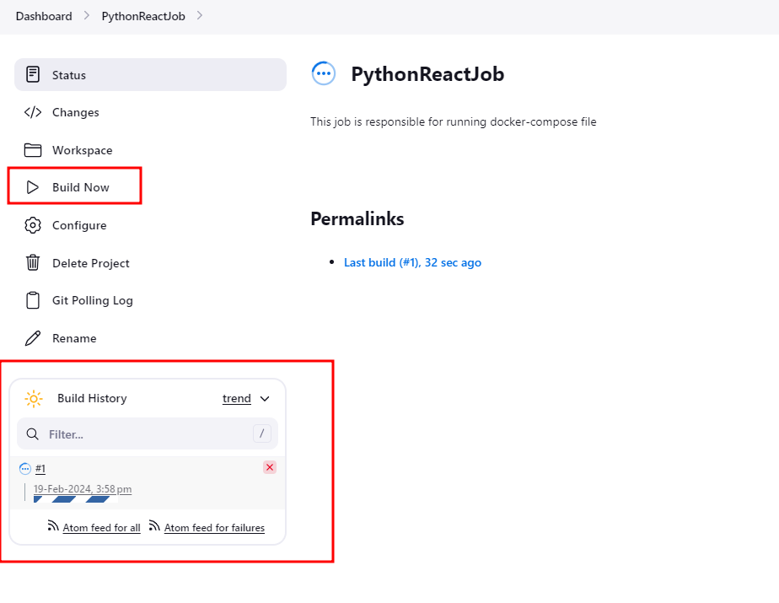

**6.8 : you can check the build status.**

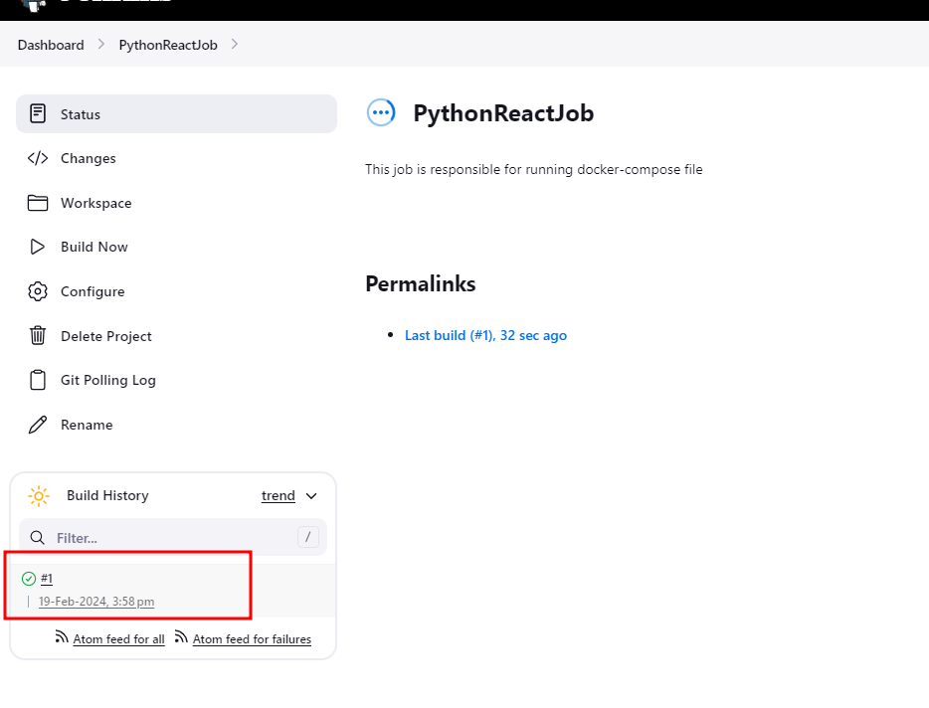

**5.12 Now click on success status and open the console**

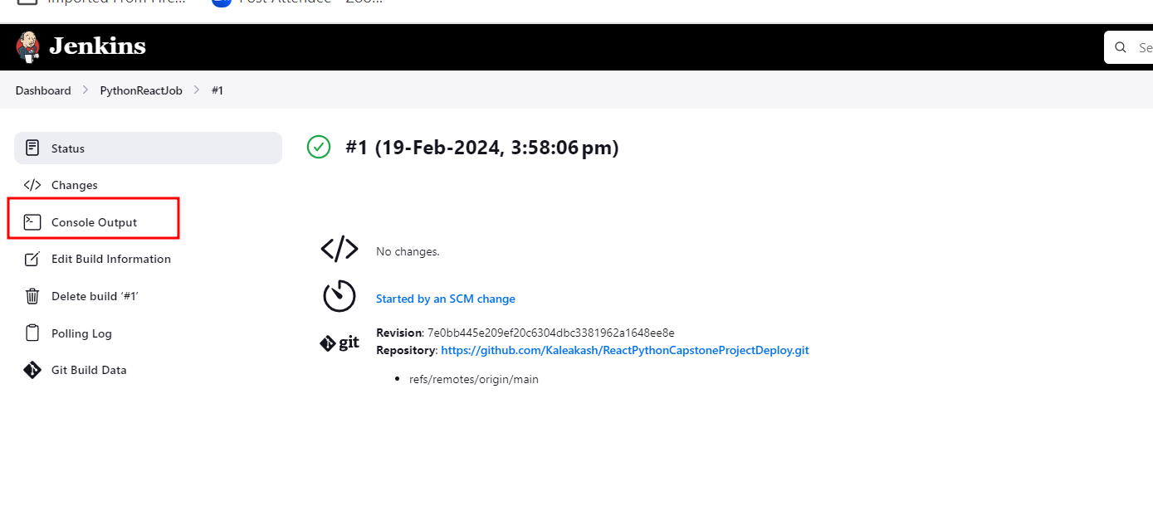

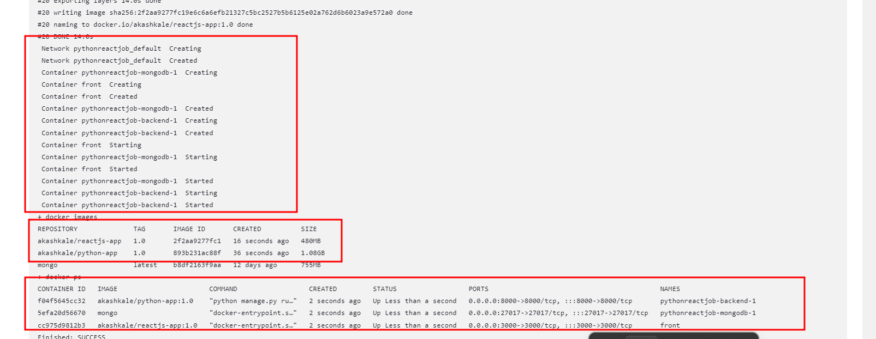

**Step 6: Test the Application**

6.1 Open the application with public instance ip address with port number 3000 for react js application.

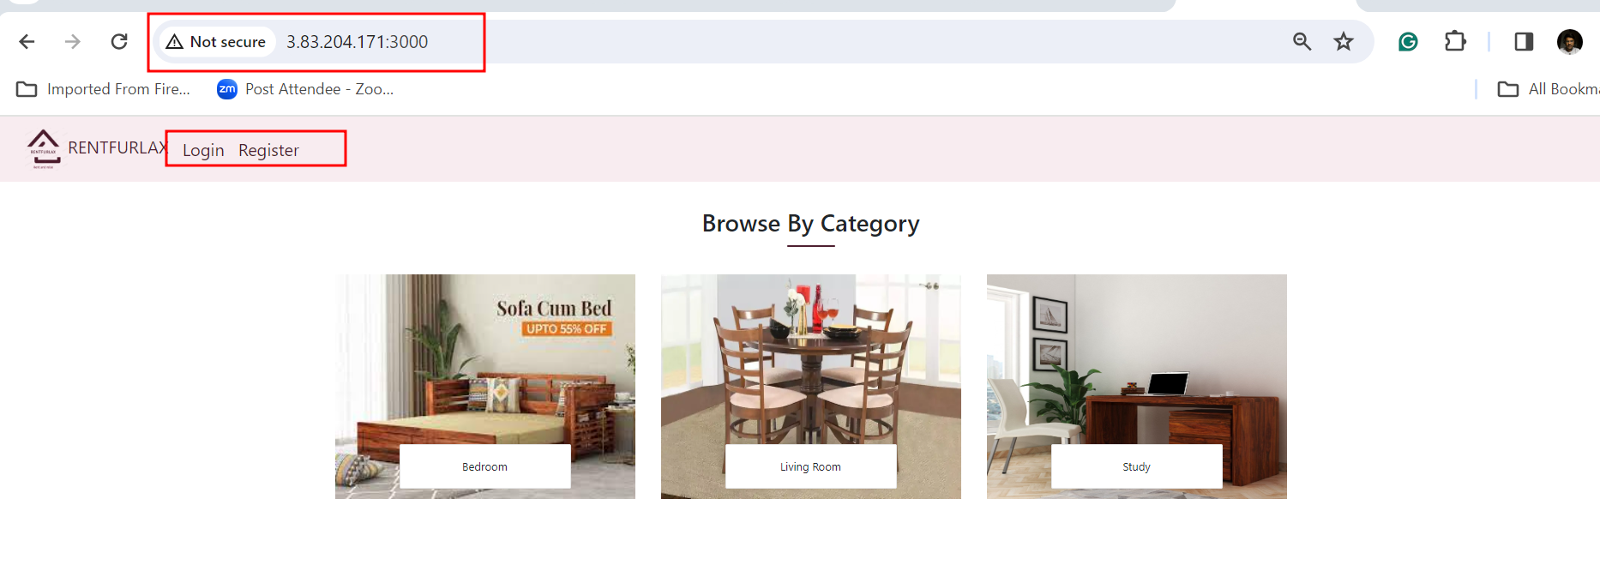

6.2 if you want to build this project whenever we push the code. Then we need to do the changes in build as first we need to kill all container using container id and run once again docker compose file.

Note : Please note down those container Id from console.

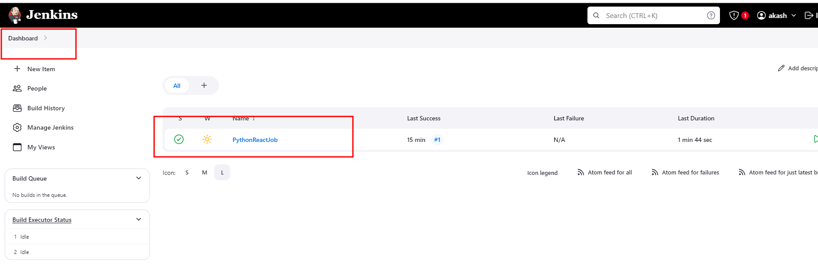

6.3 Right click on project and select the option as configure. If you need to do any changes in existing job.

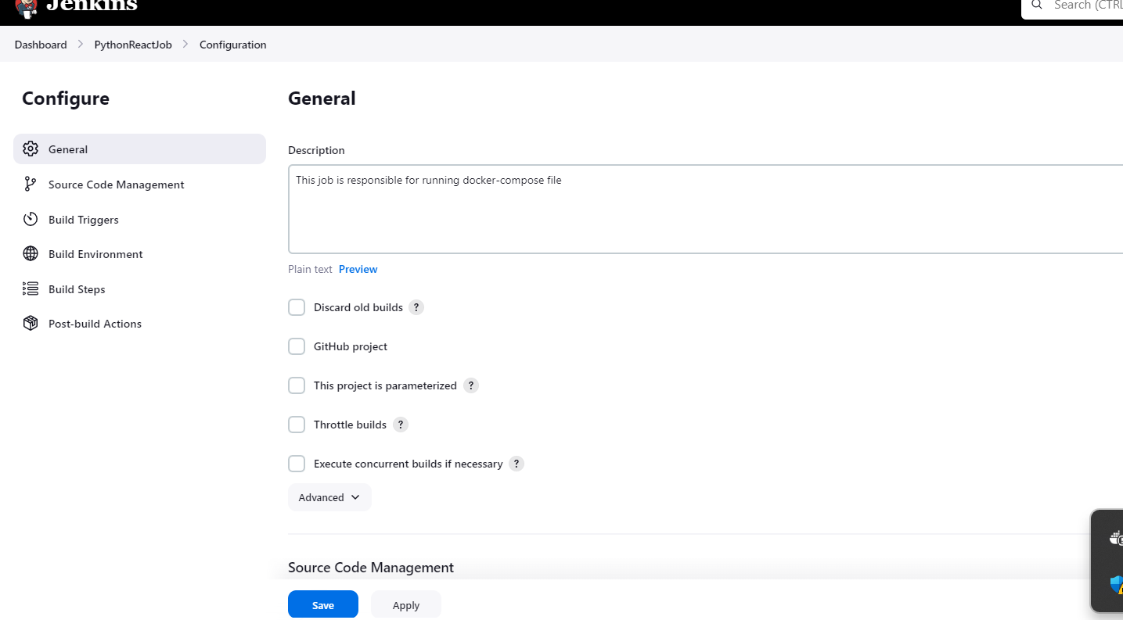

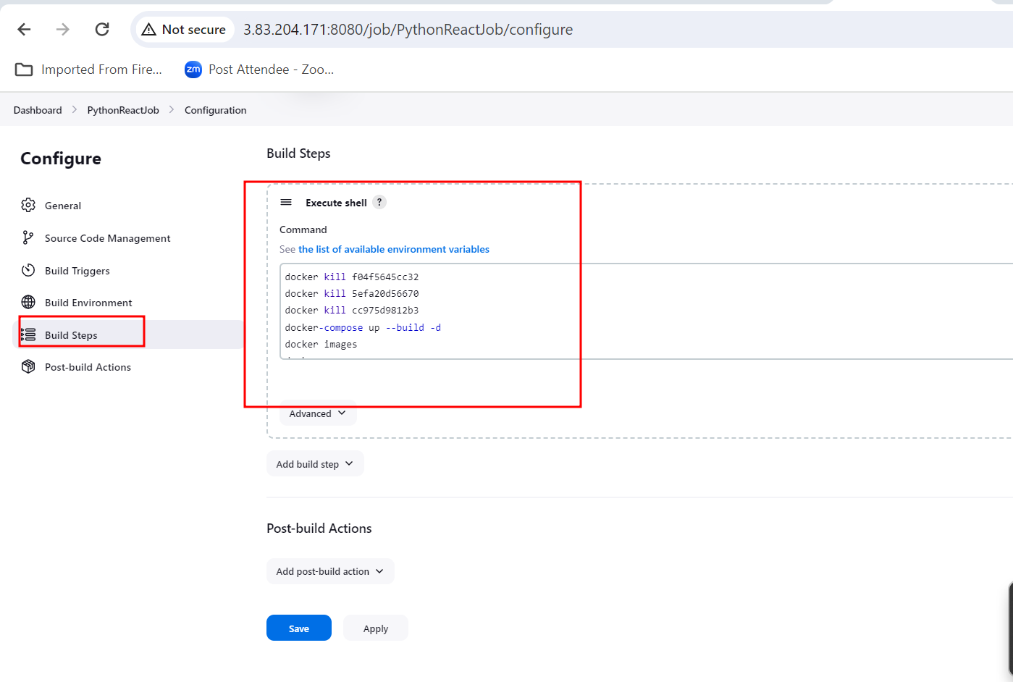

6.4 Add save the job once again.

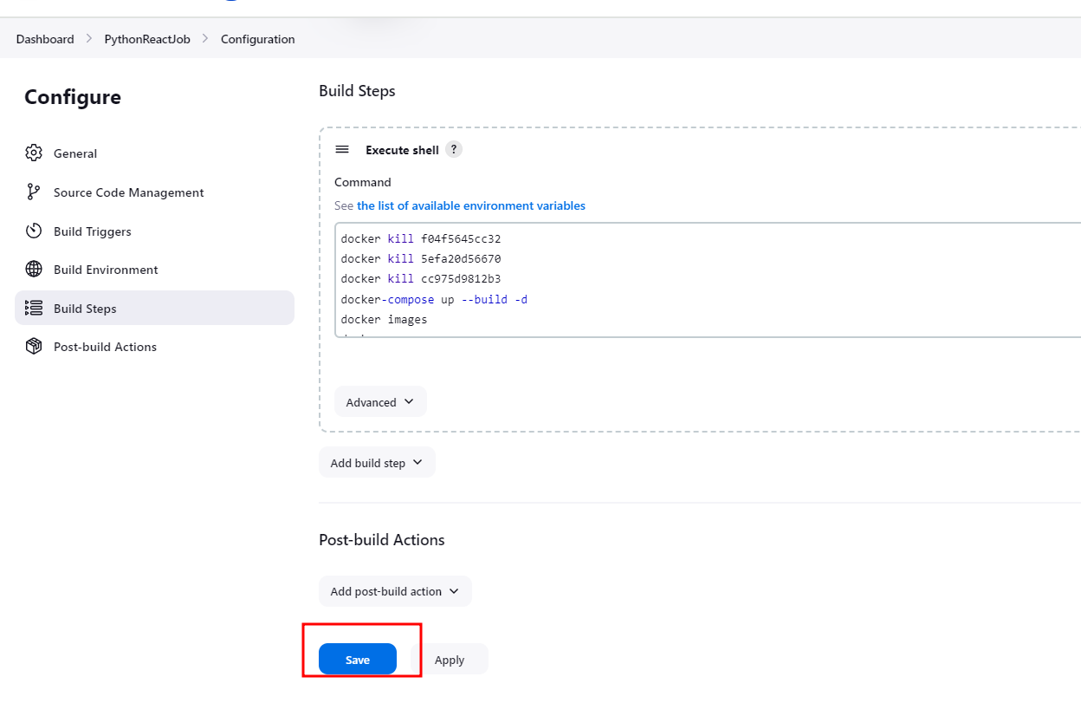

6.5 Now we do the changes in login.js file as change the title

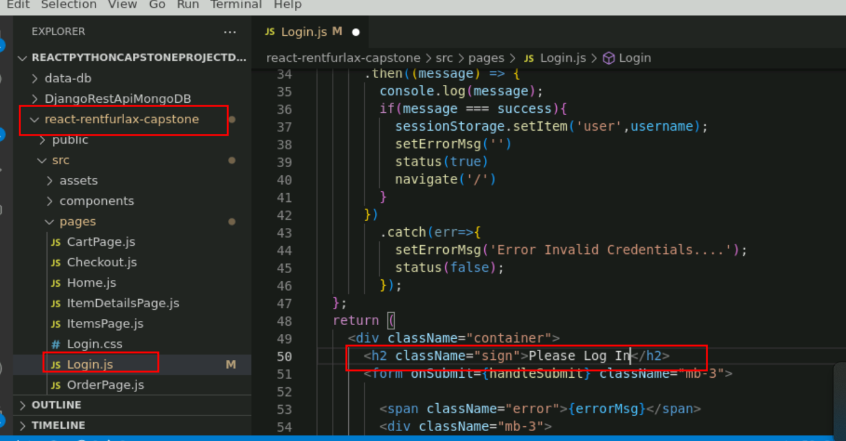

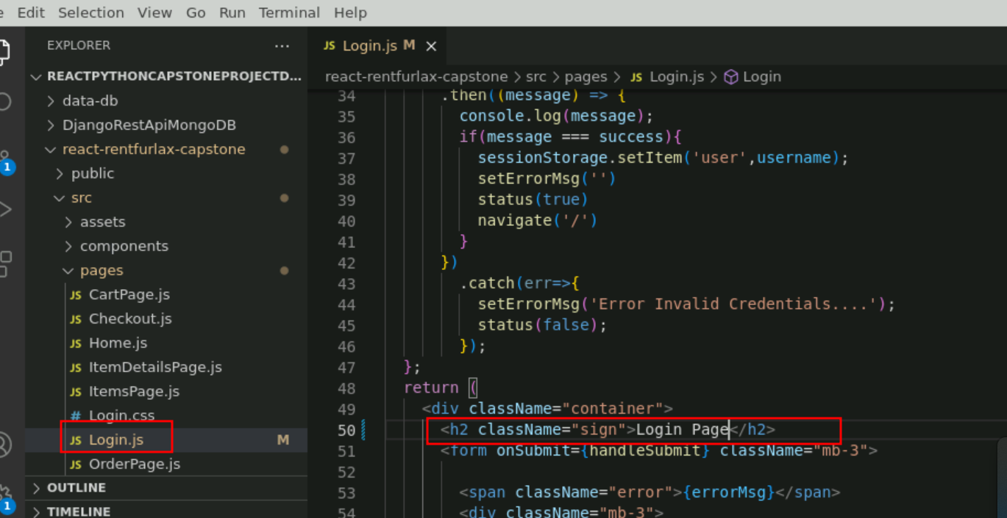

6.6 After changes. Please execute below command to push the code in Git hub account.

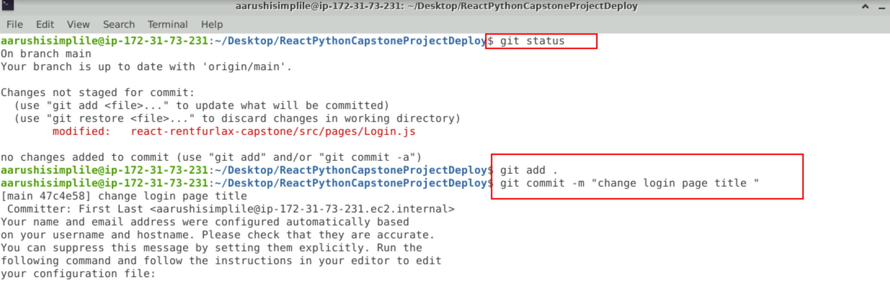

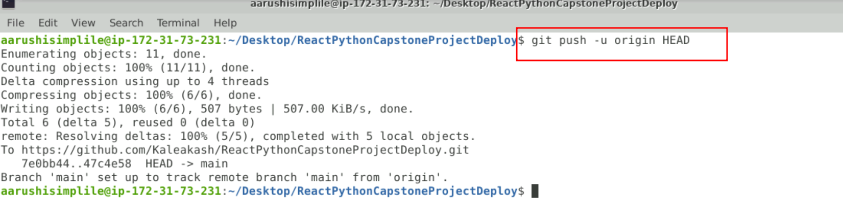

6.7 Whenever you push the code automatically Jenkin will build the project and you can see the changes in the application.

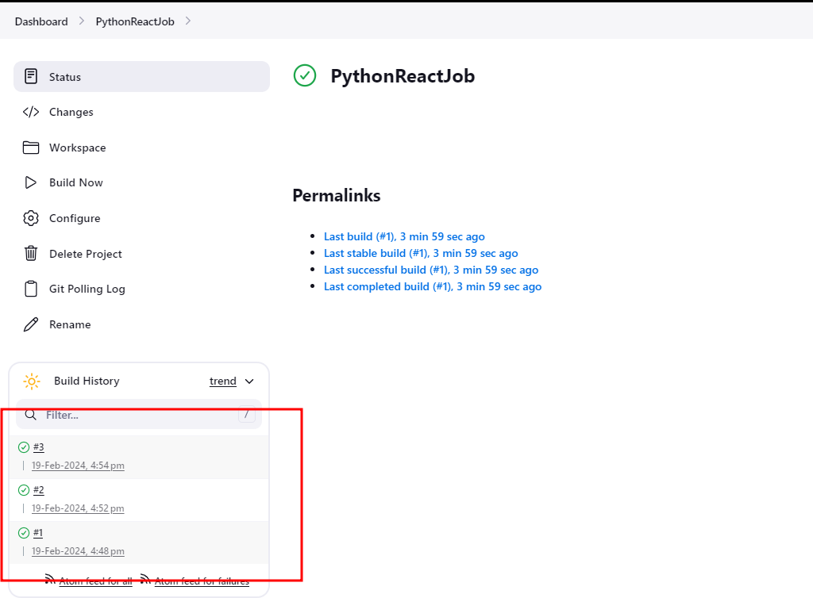

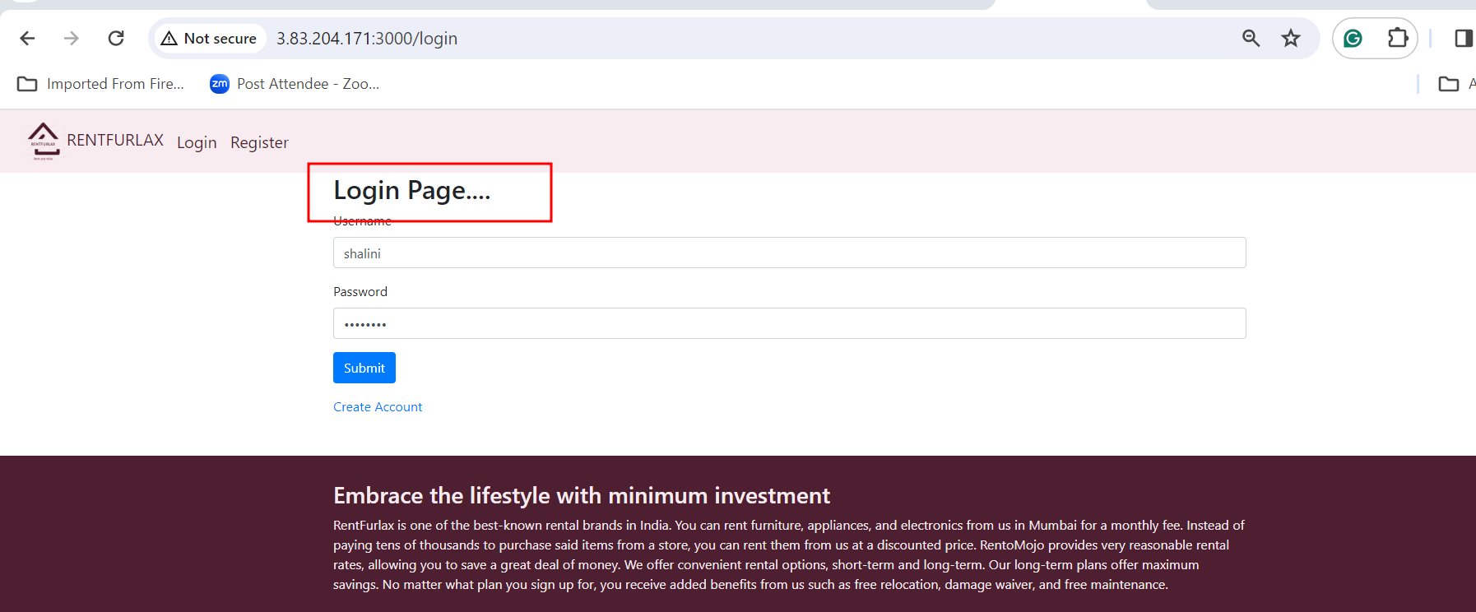

6.8 Register

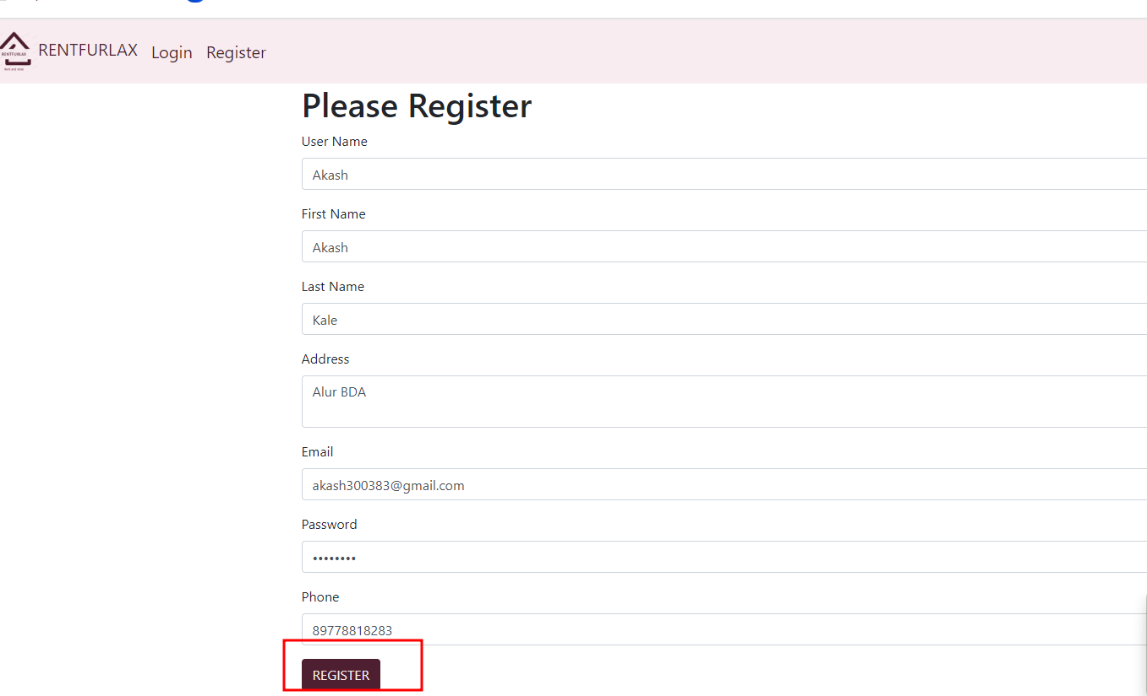

After registered you can login now

